MODULE 12:- Terraform
Terraform Overview
SUBMITTED BY :- CHANDAN YADAV KS
SUBMITTED TO :- VIKUL
DATE OF SUBMISSION :- 23-07-2025

1. L1 - Provision AWS EC2 Instance along with VPC, Subnet, Internet Gateway, Route-Table, Route Table Association, Security Group
Step1: lunch the instance and connect
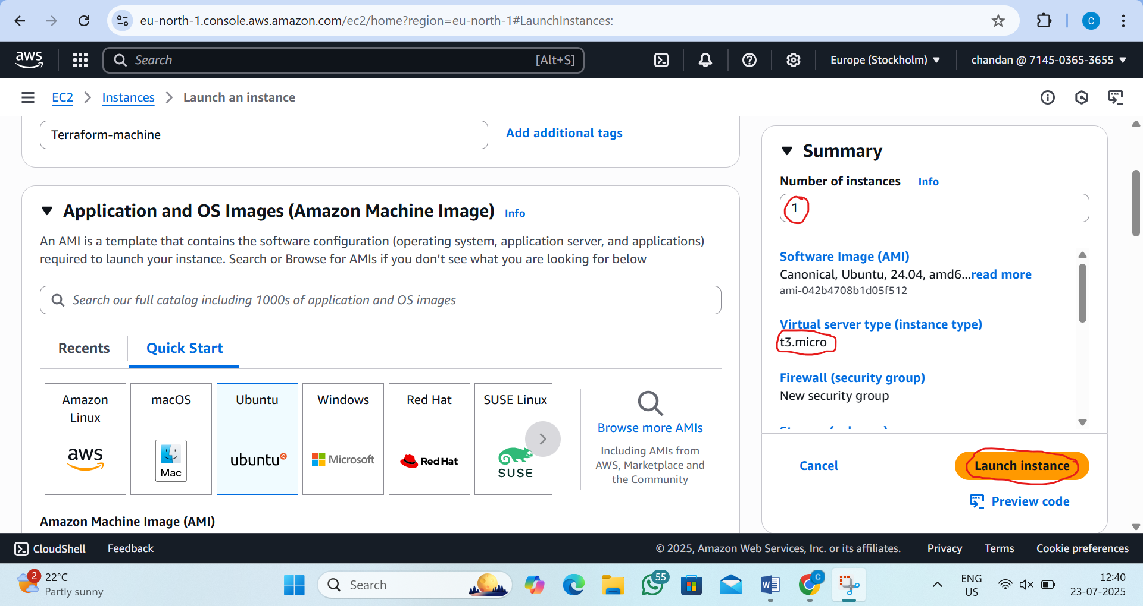
Step2:go to root user
by the command:sudo su
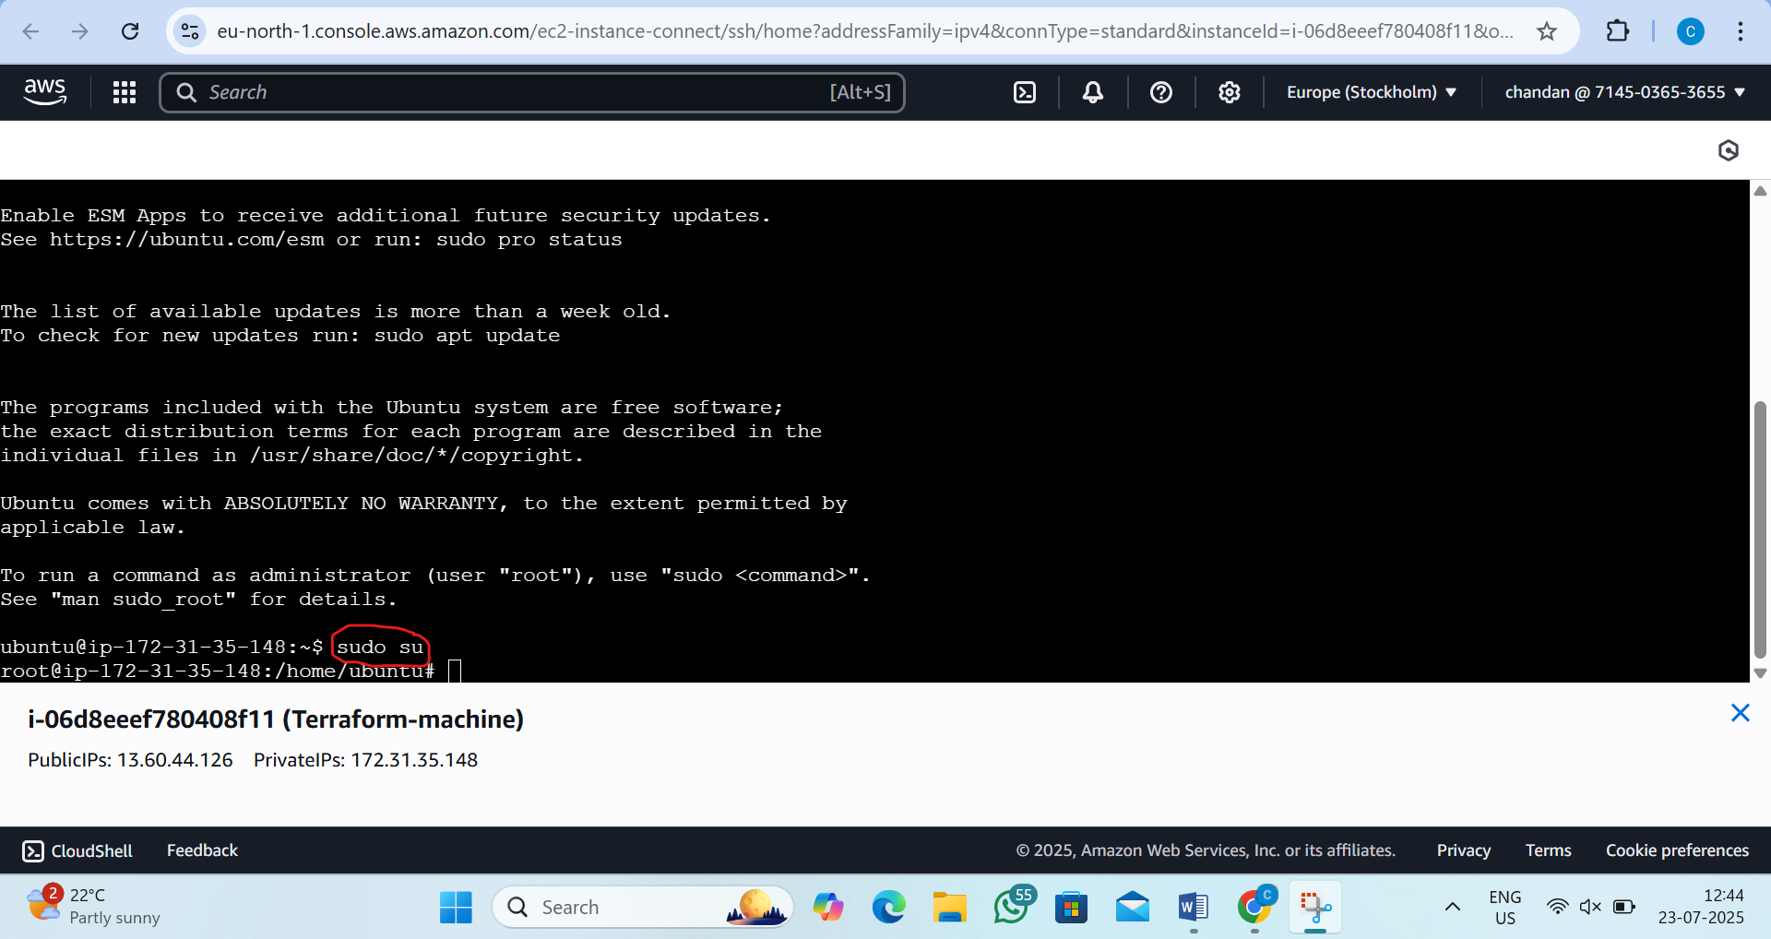

Step3:update the all pakages
by the command:- apt update
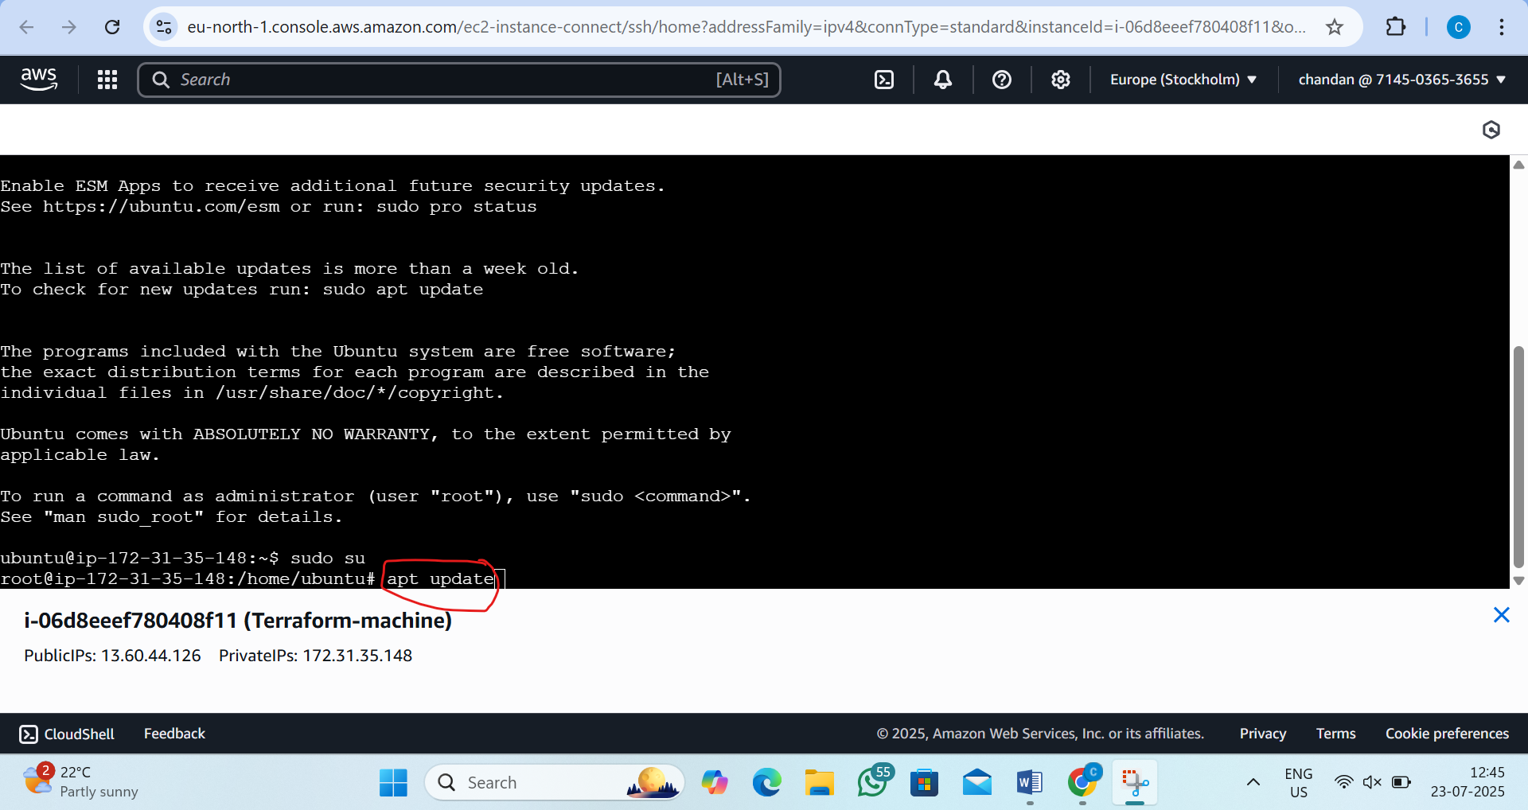
Step4:now go to terraform.io website and there will be install button
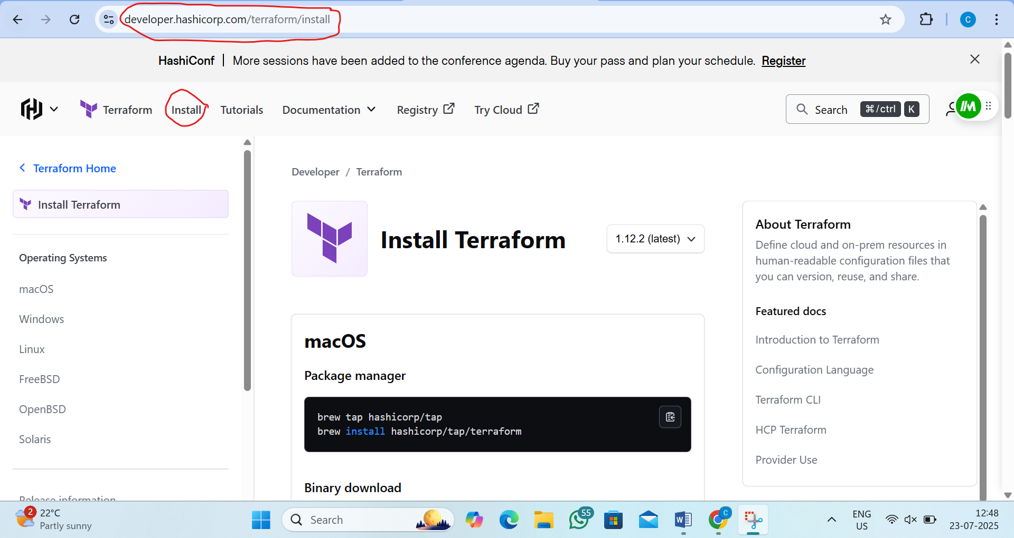

Step5: go to linux and there we will see the ubunto copy this command
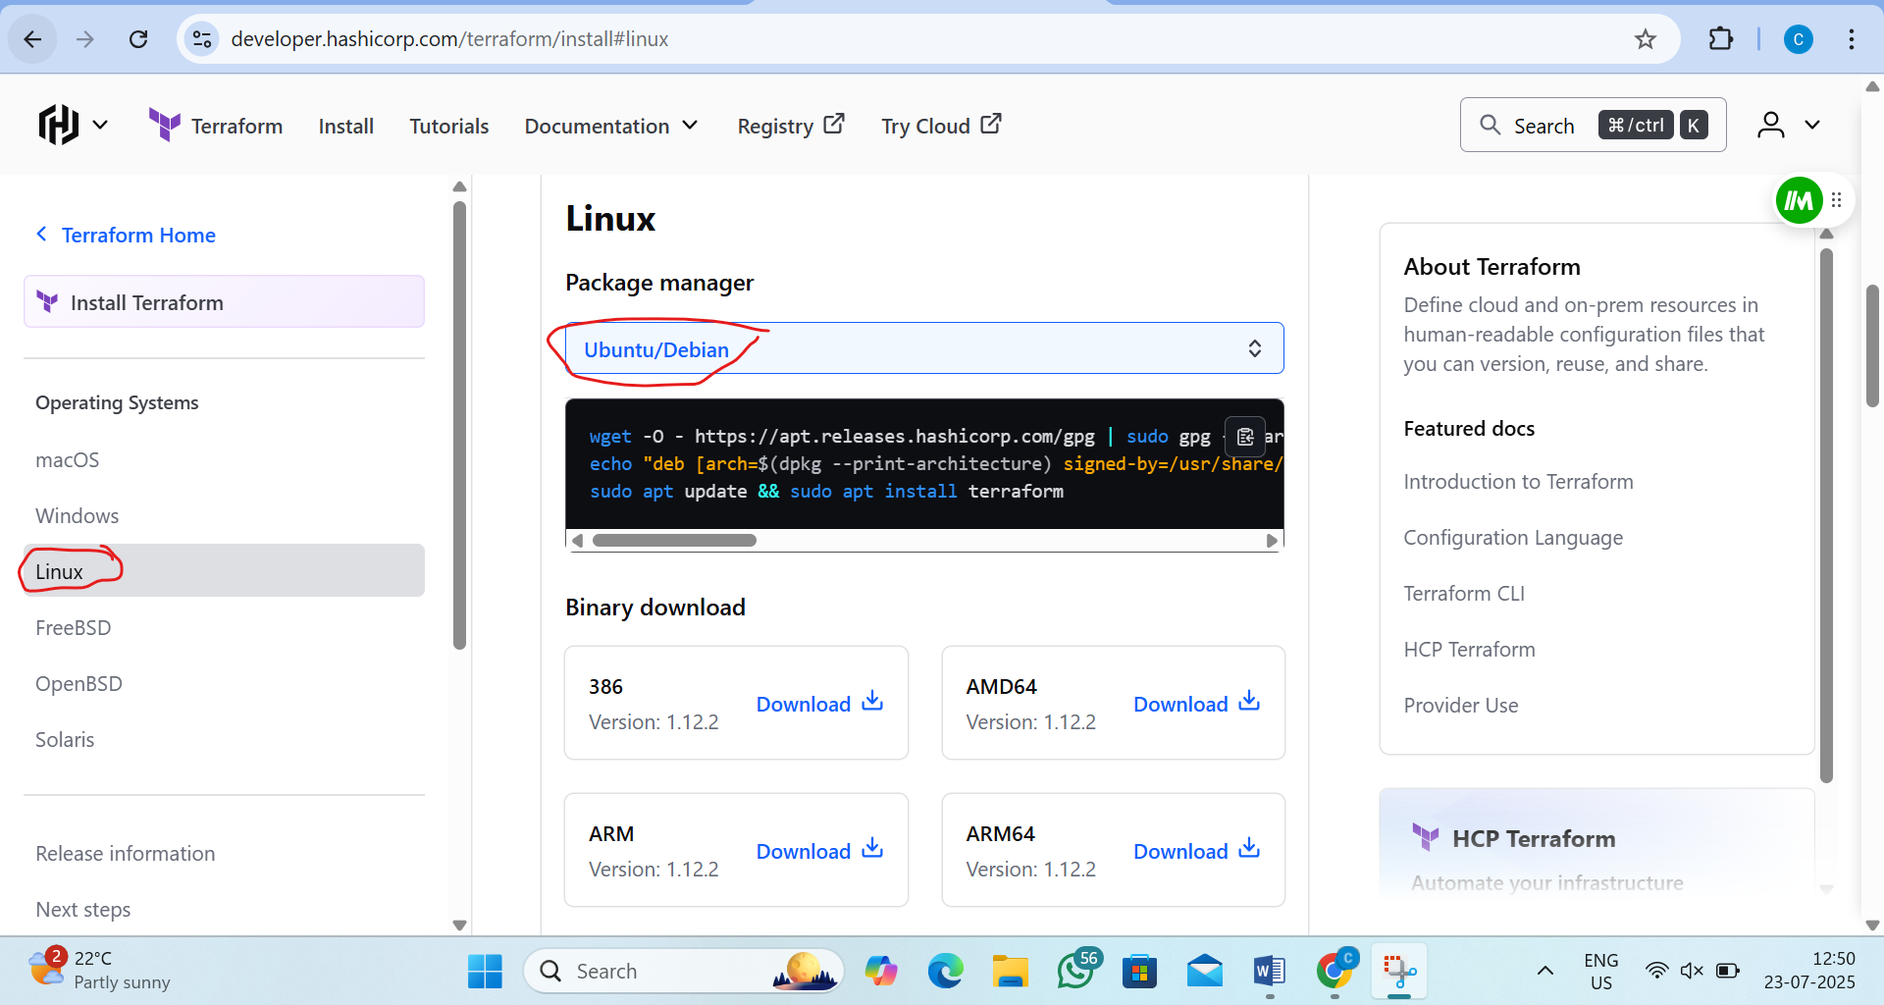
Step6:- run that command in instance
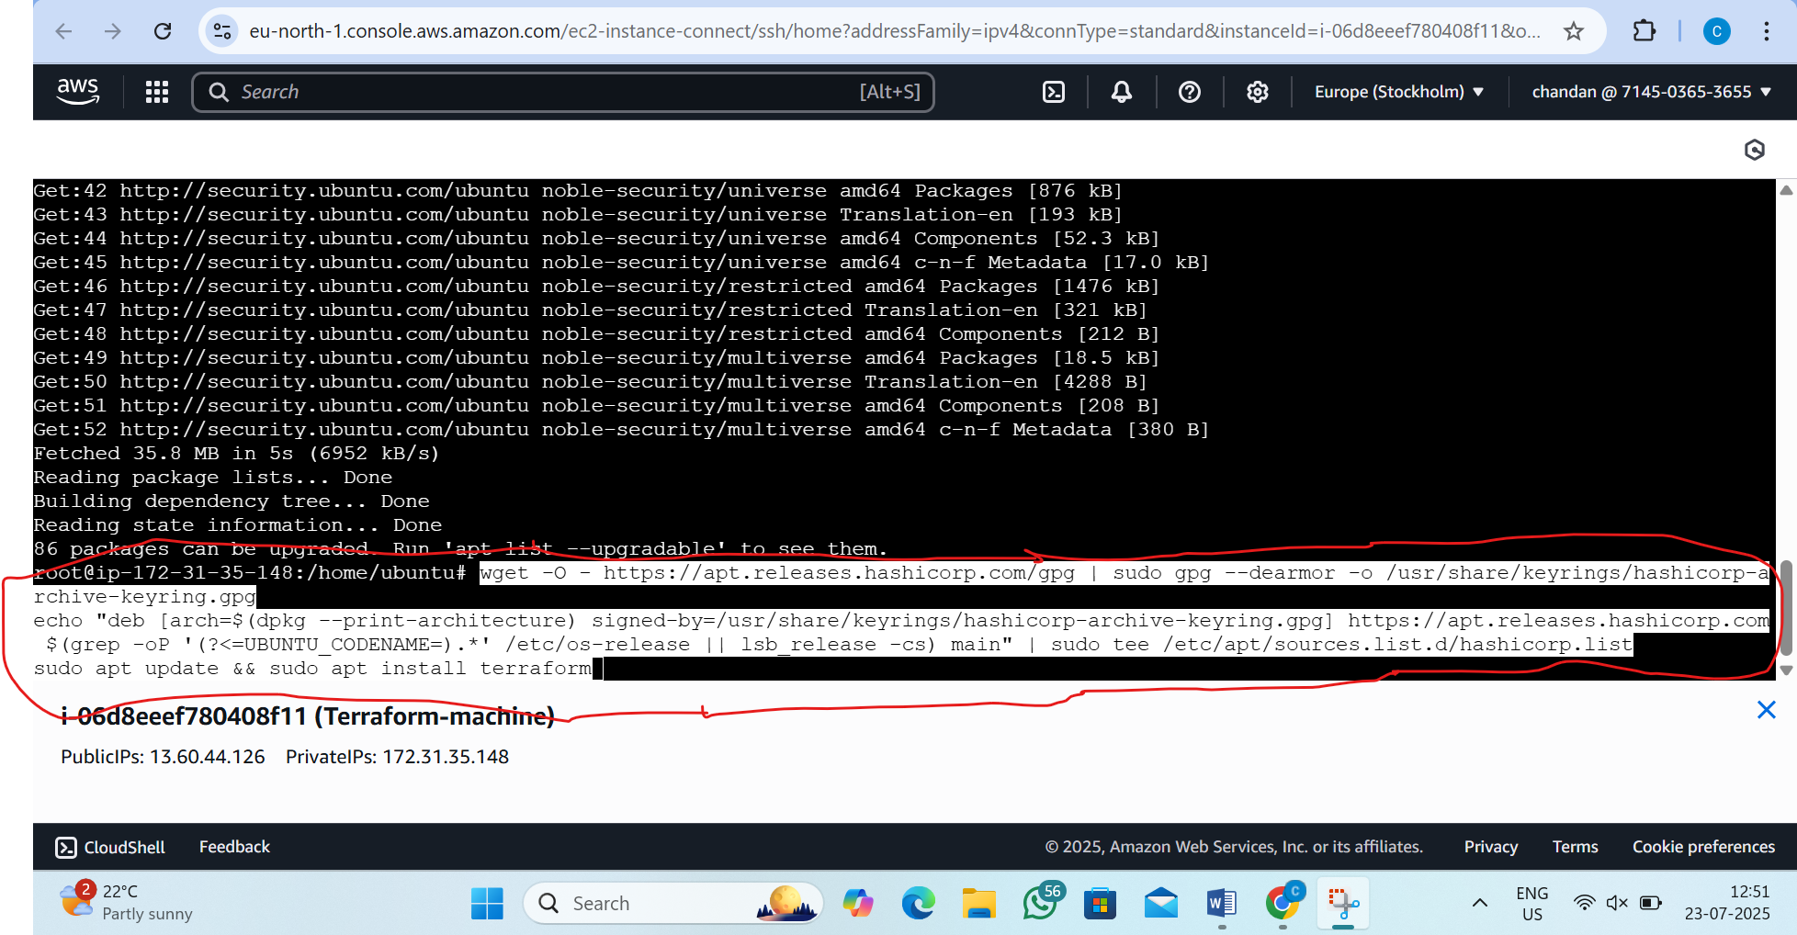

step7: now see terraform version
by the command:- terraform --version
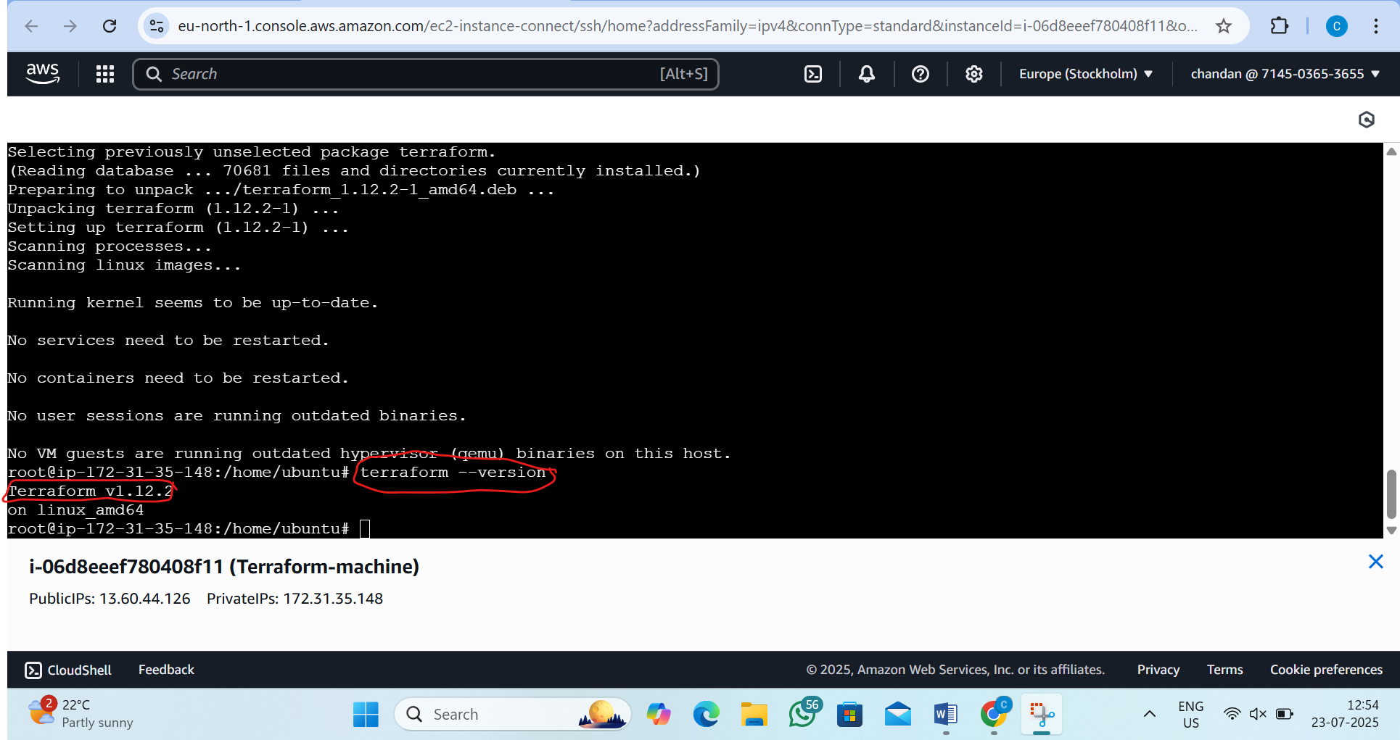
Step8: now create the new directory and go to that directory
by the command:1) mkdir terraform-script
2)cd terraform-script
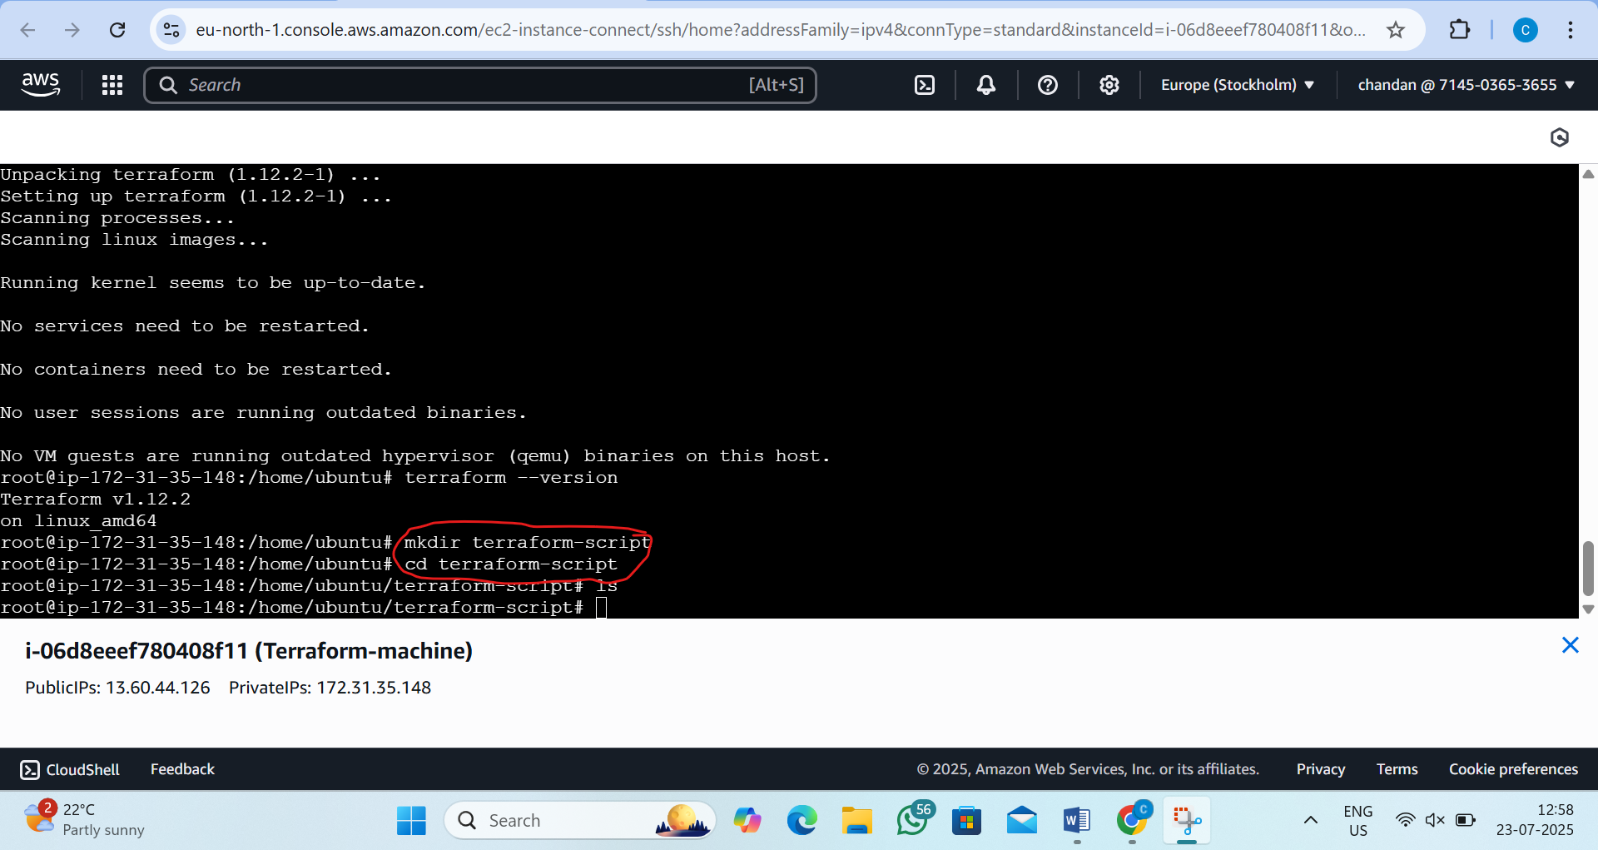

Step9:-now create connection file
by the command:-vi connection.tf
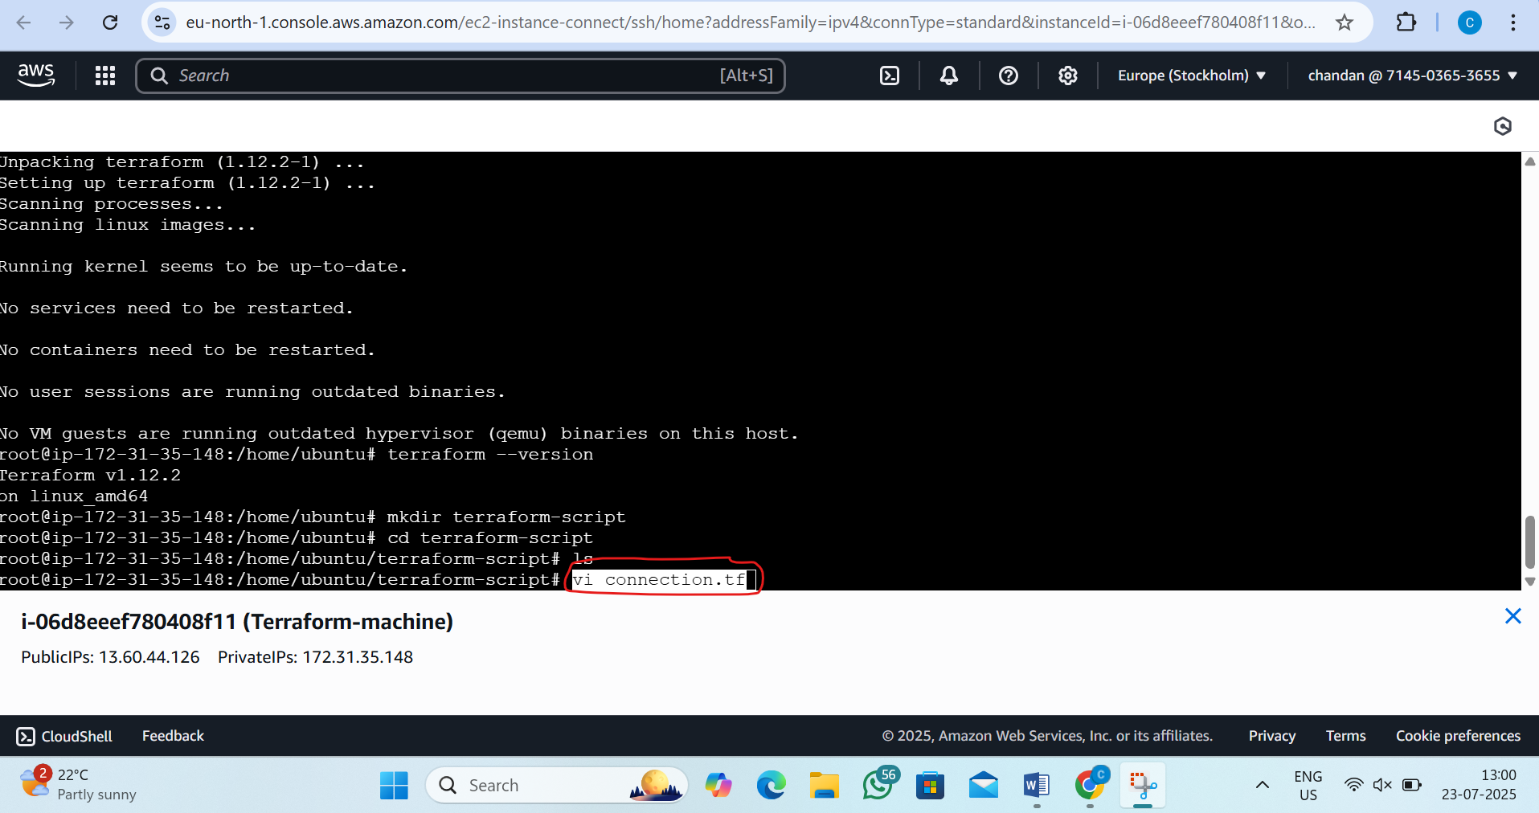
Step10:now go to terraform.to webside and click on registry and now click on browser provider and go to aws and click on documentation and scroll down and copy the provider
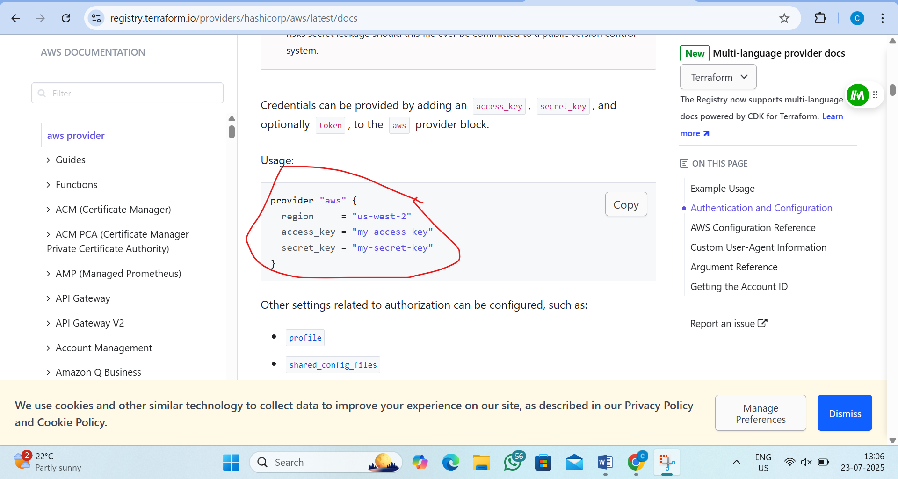

Step11:now inside the connection file we want to paste that (lets keep like this only now because we want to chane the acess-key and secret key)
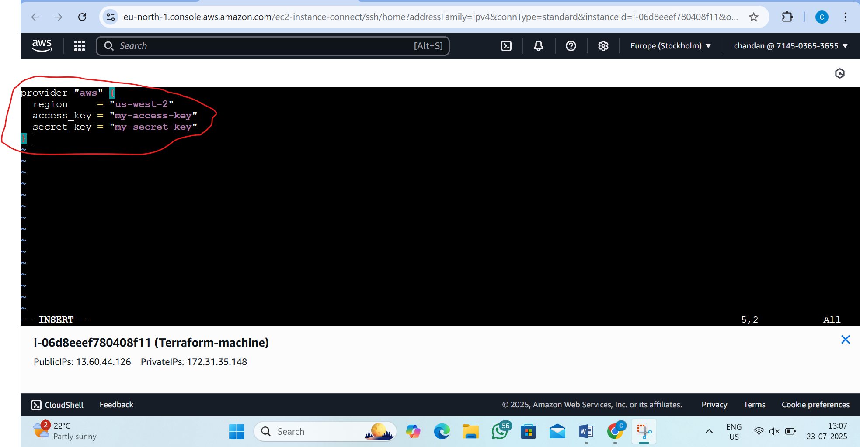
Step12:now we want generate access key and secrate key by the following step
1)go aws account and go to home
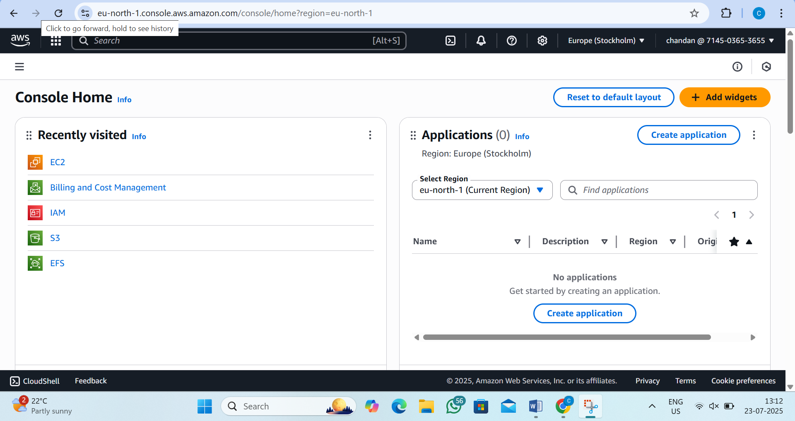

Step13:now click on name and we will see the security credential click on that
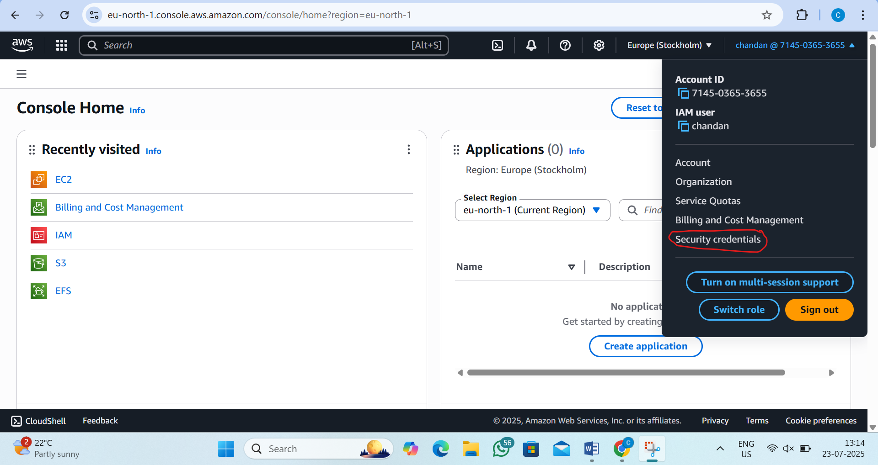
Step14:now scroll down and see the access key and generate access key
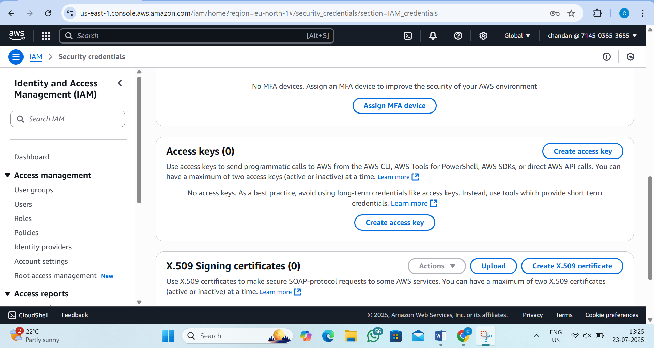

Step15:-select local code
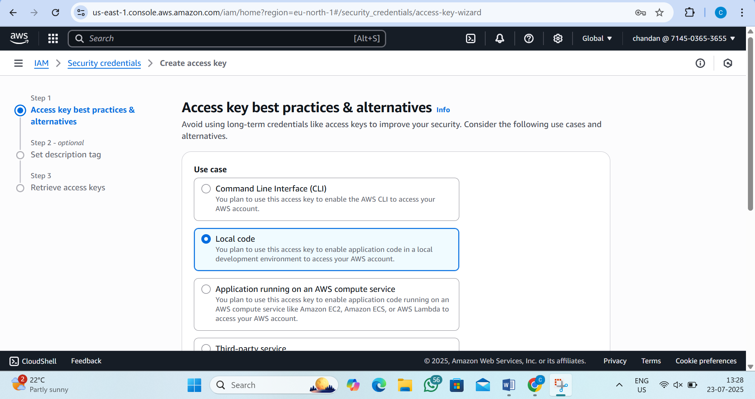

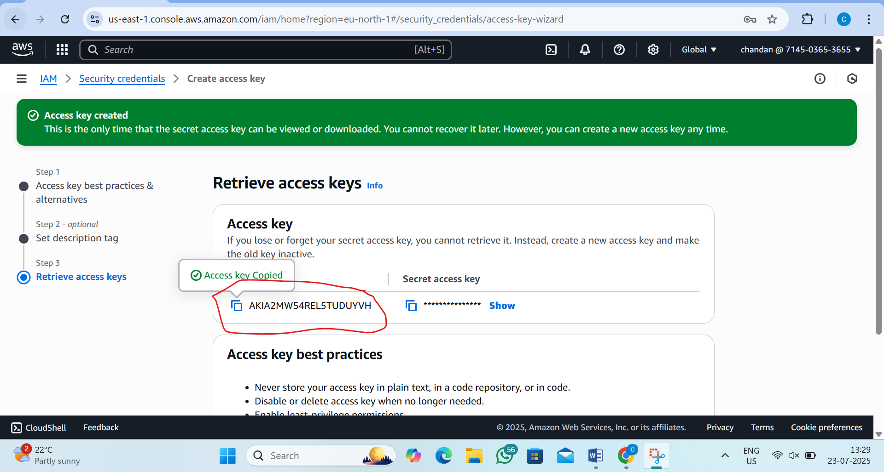

Step16:now go to connection file change the region and paste the generated access key and secret-key
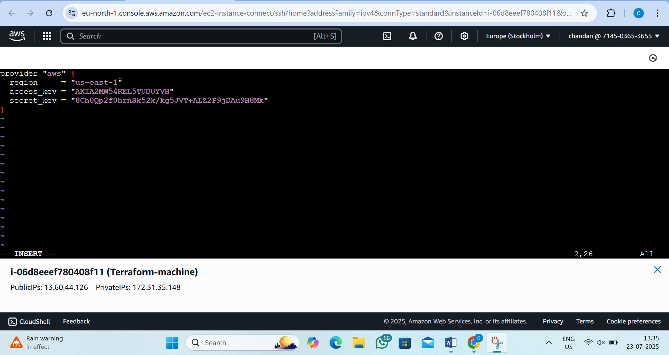

Step17:now create the file to create the ec2 machine
by the command:-vi ec2.tf
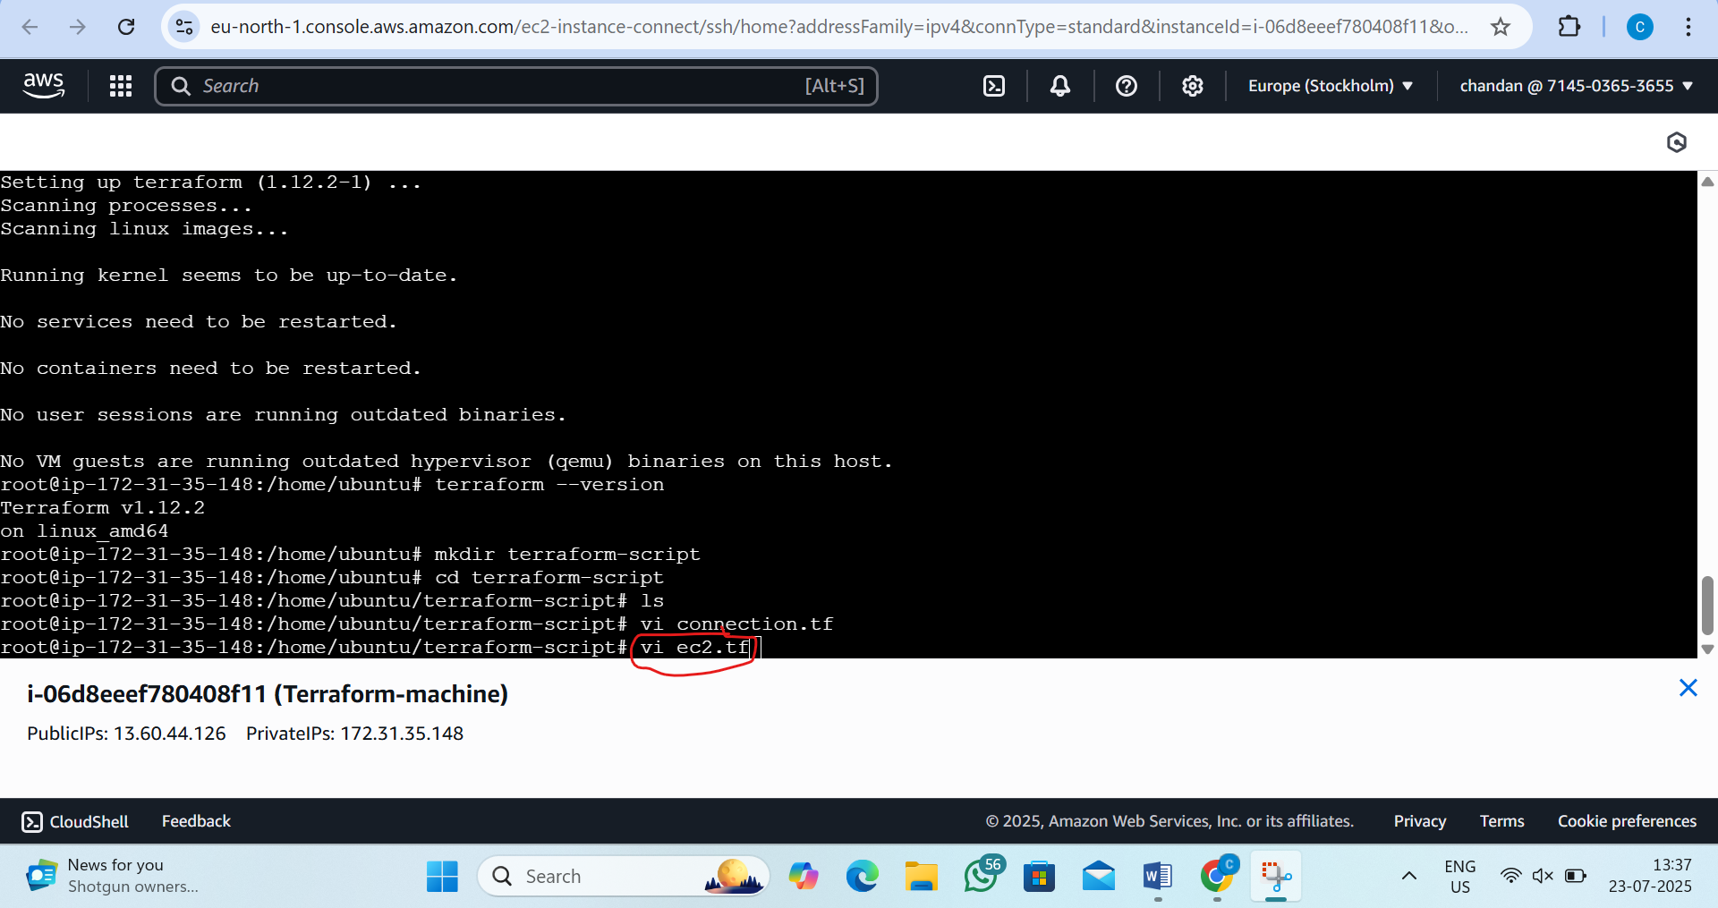

Step18:see in the N-virginia no machine is created
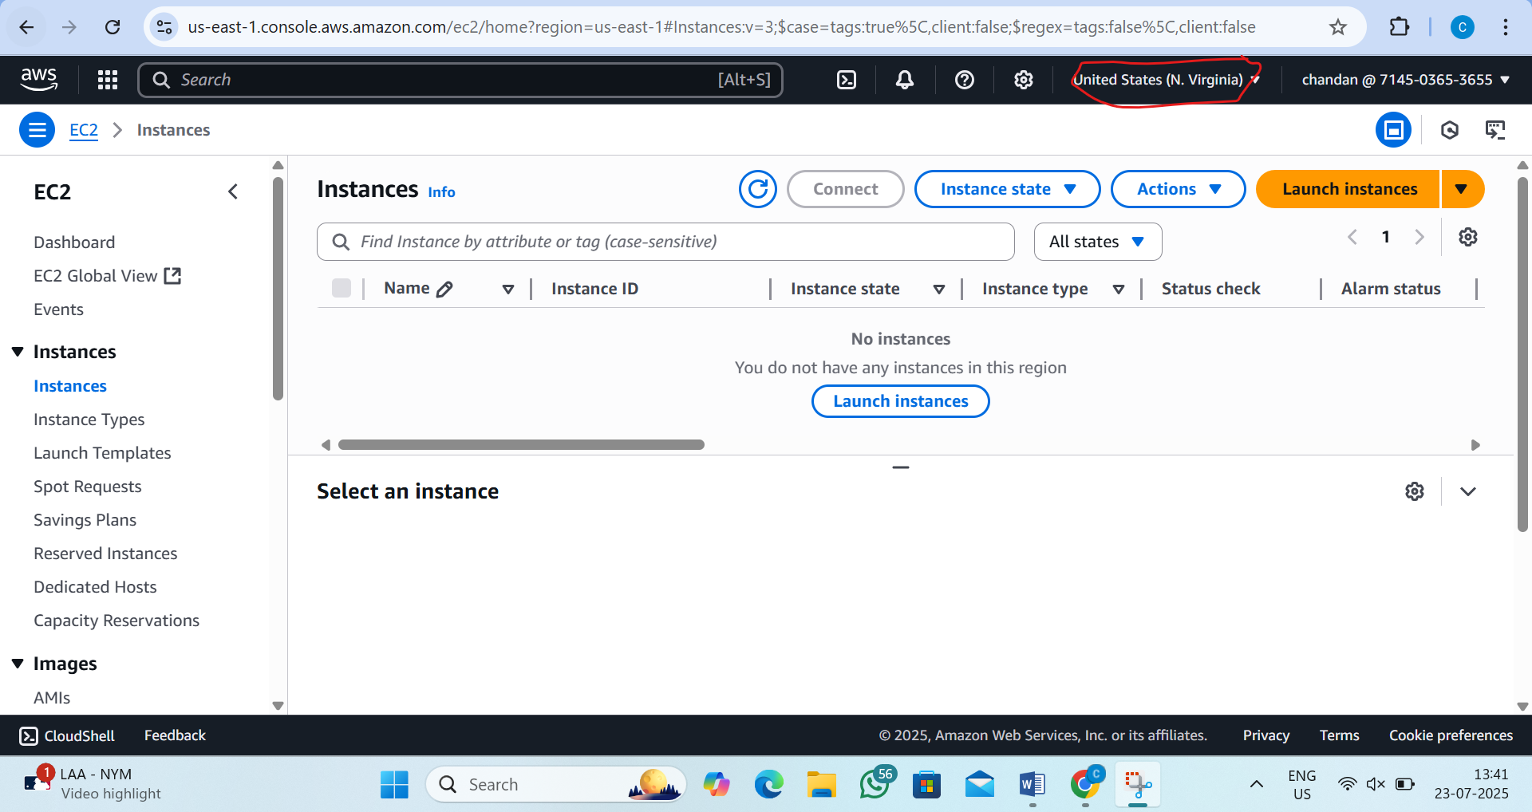
Step19:now in the ec2.tf I will create the ec2 instance in the N-virginia by the following steps
i)now go to terraform.io and go to registry button and go to aws documentation and now in search ec2 there and scroll down there and see aws_instance click on that and there copy the resource
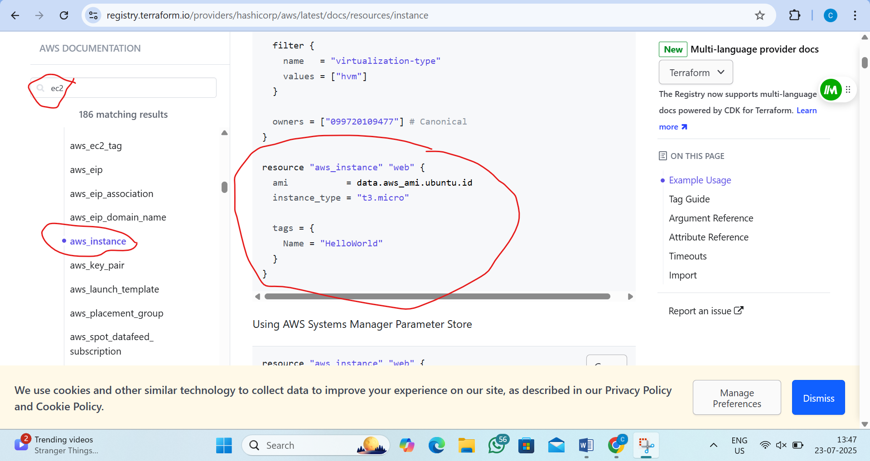

Step20:now paste the resource in the ec2.tf file
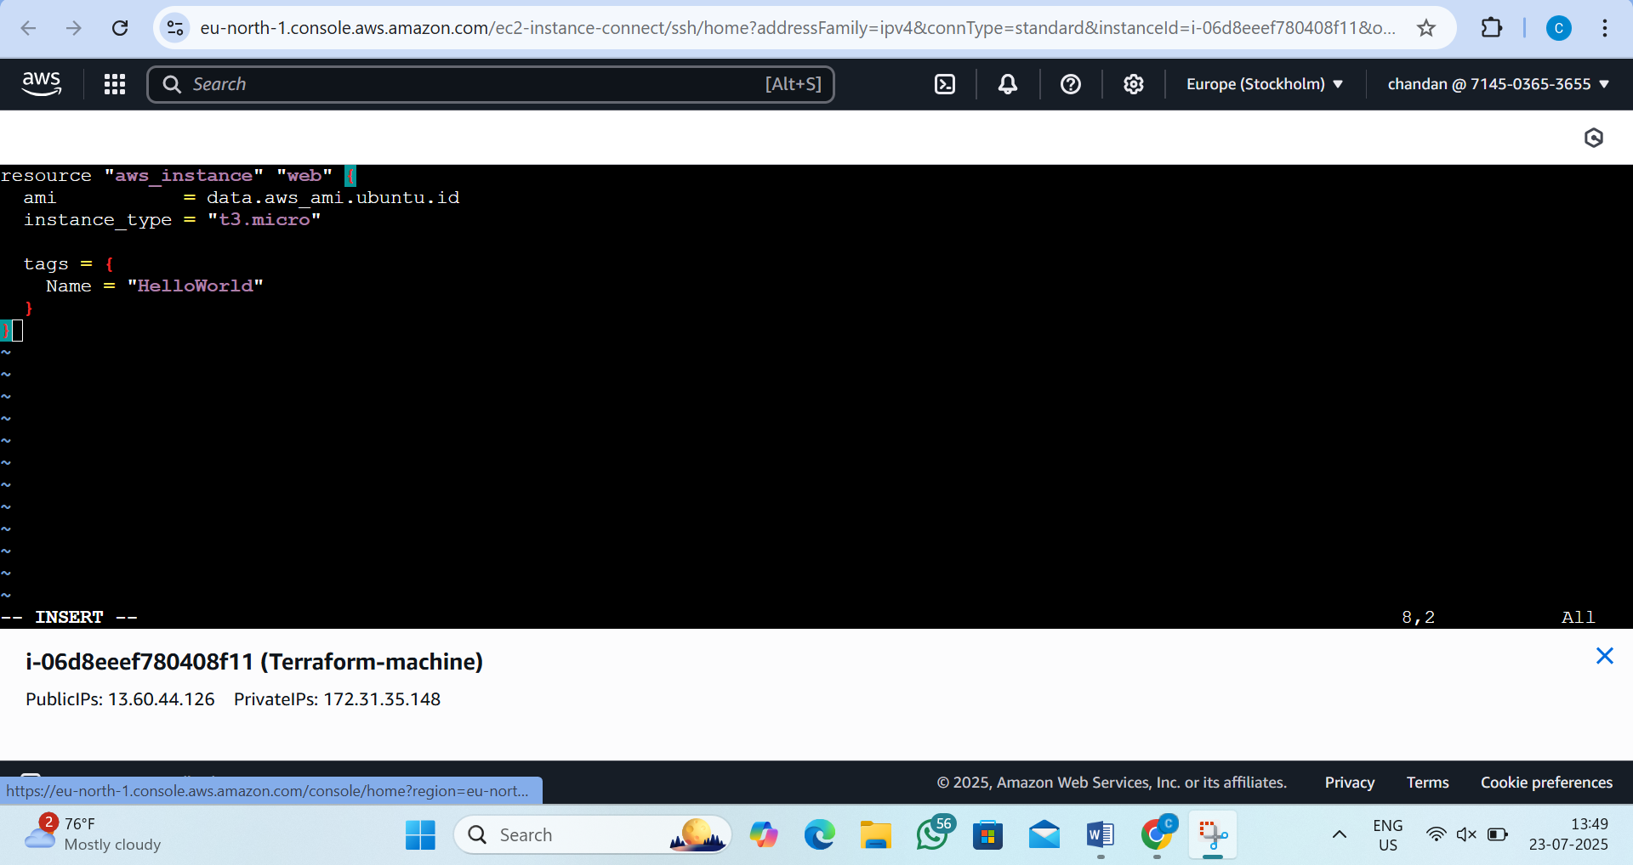
Step21:now we want copy the ami id (ubunto) of n-verginia region
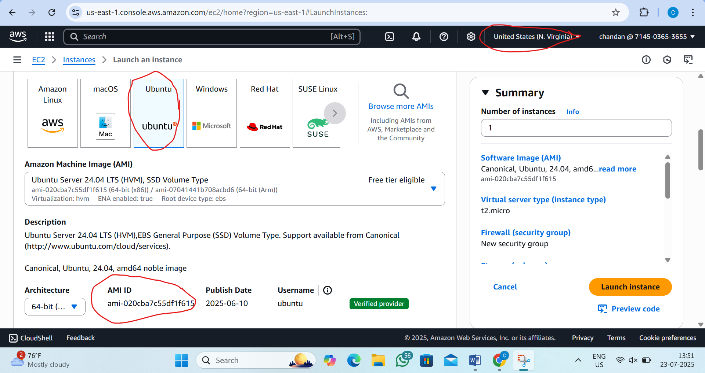

Step22:now copy that ami id and paste insde the resource of ec2.tf file
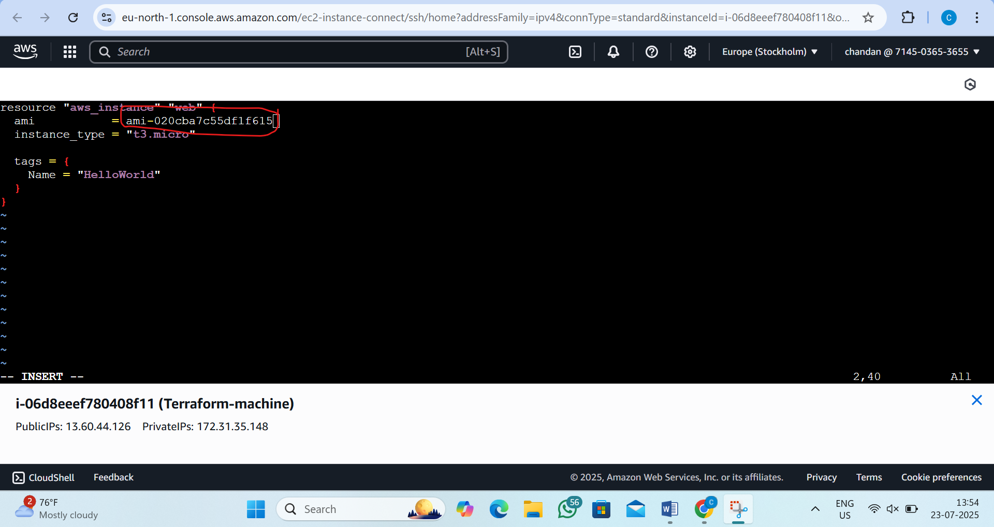

Step23:now execute this code by the following command
by the command:-1)terraform init
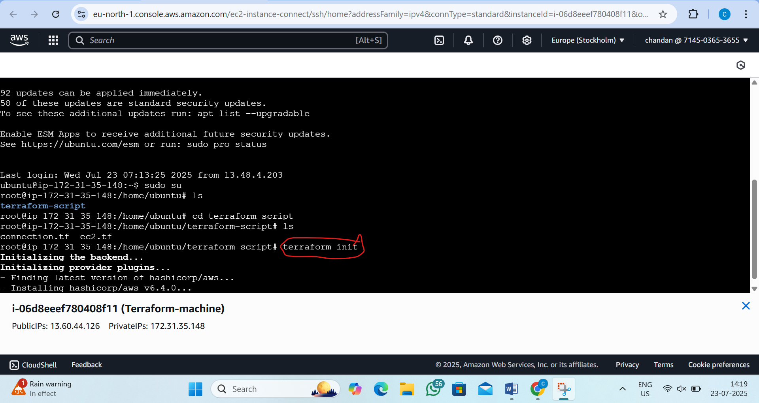

2)terraform apply --auto-approve
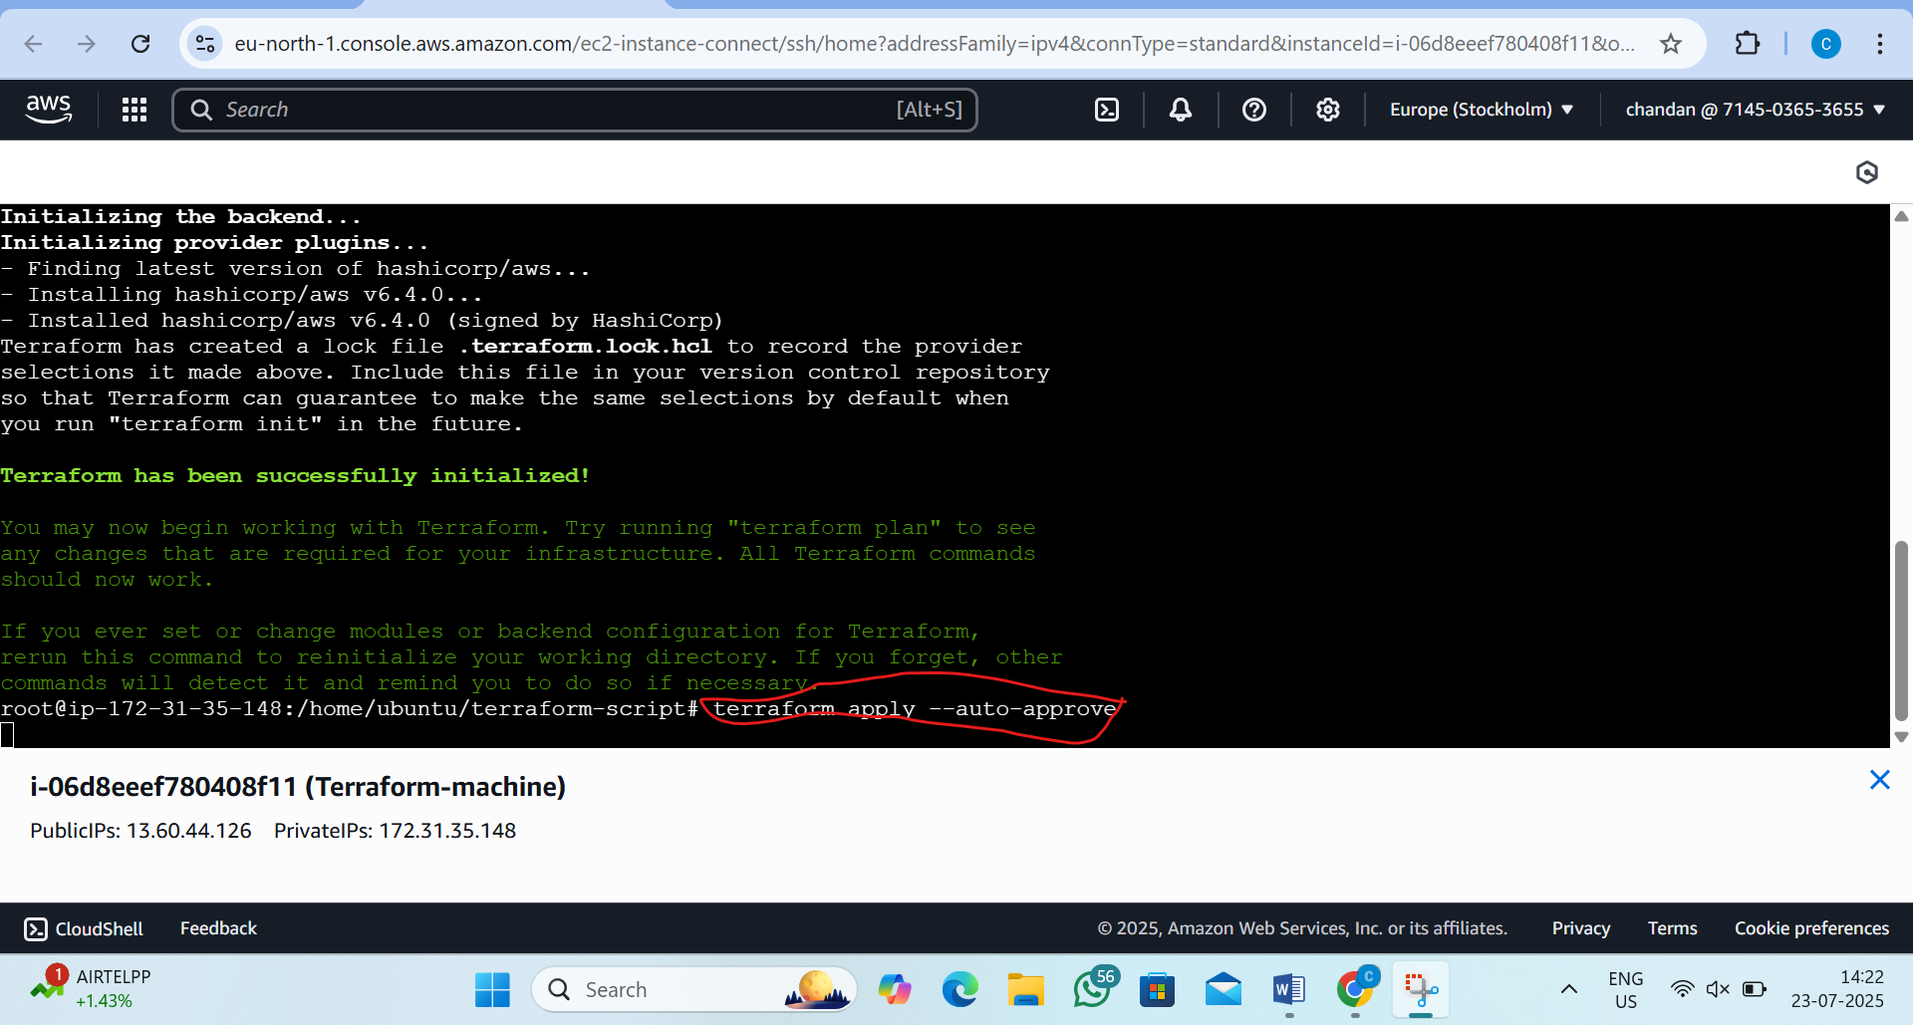
3)output is
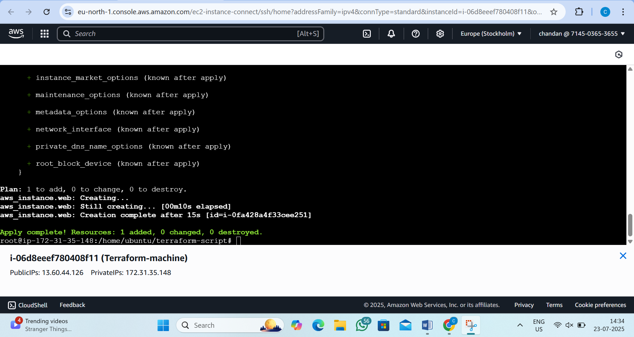
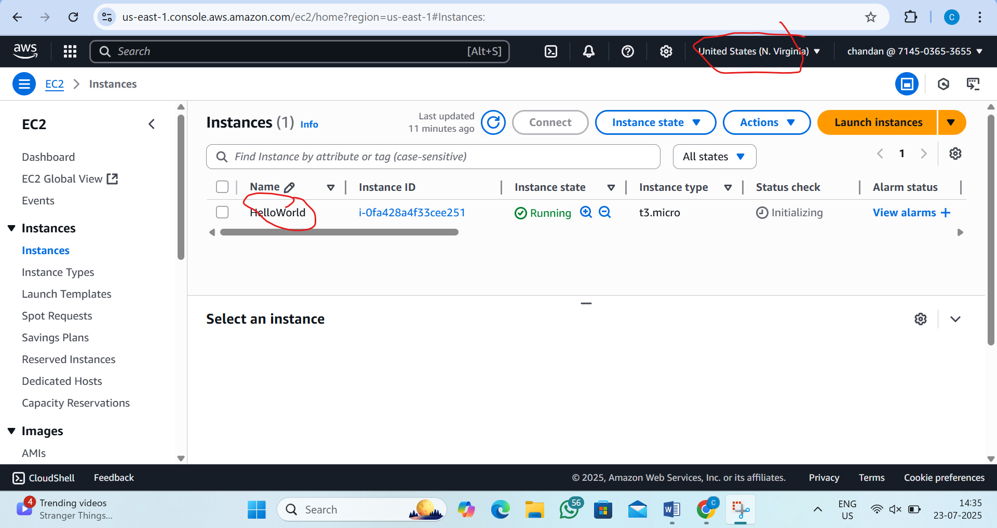

Step23:now create file vpc.tf
by the command :-vi vpc.tf
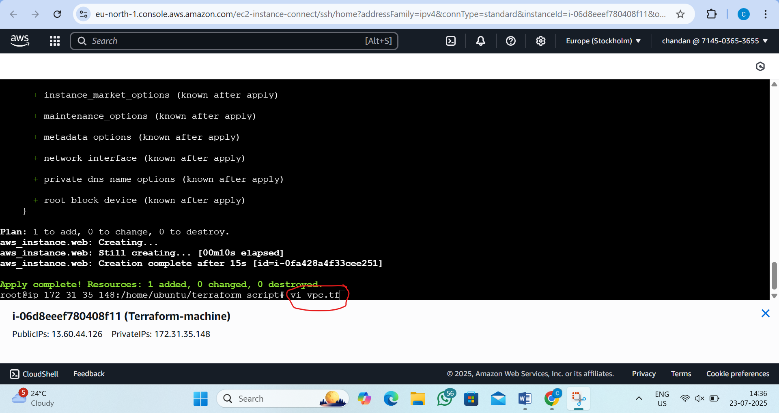

Step24:now paste this inside that
resource "aws_vpc" "main_vpc" {
cidr_block = "10.0.0.0/16"
}
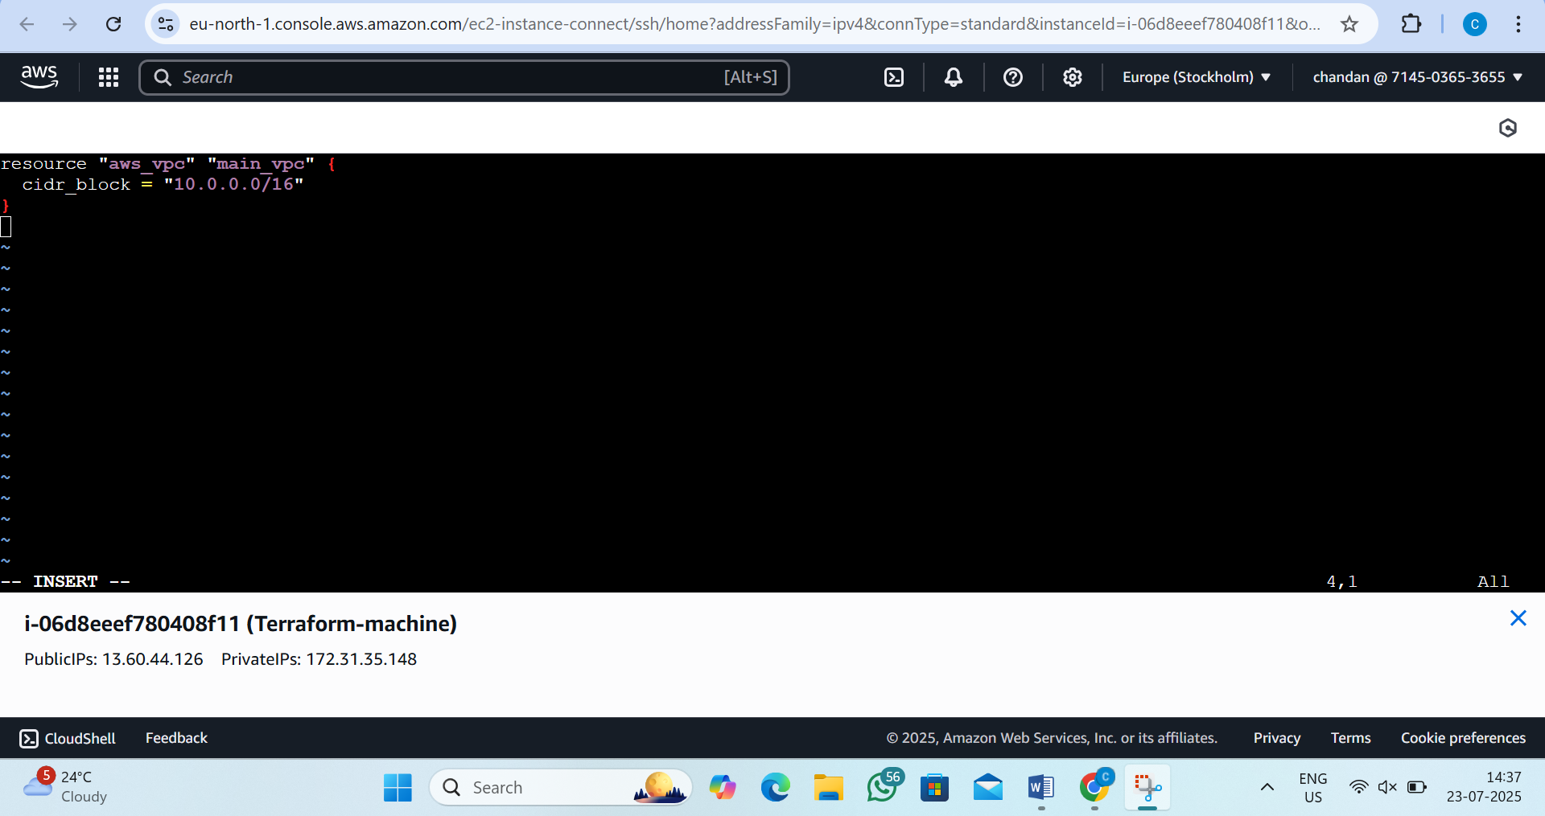
Step25:create subnet.tf file
by the command:vi subnet.tf
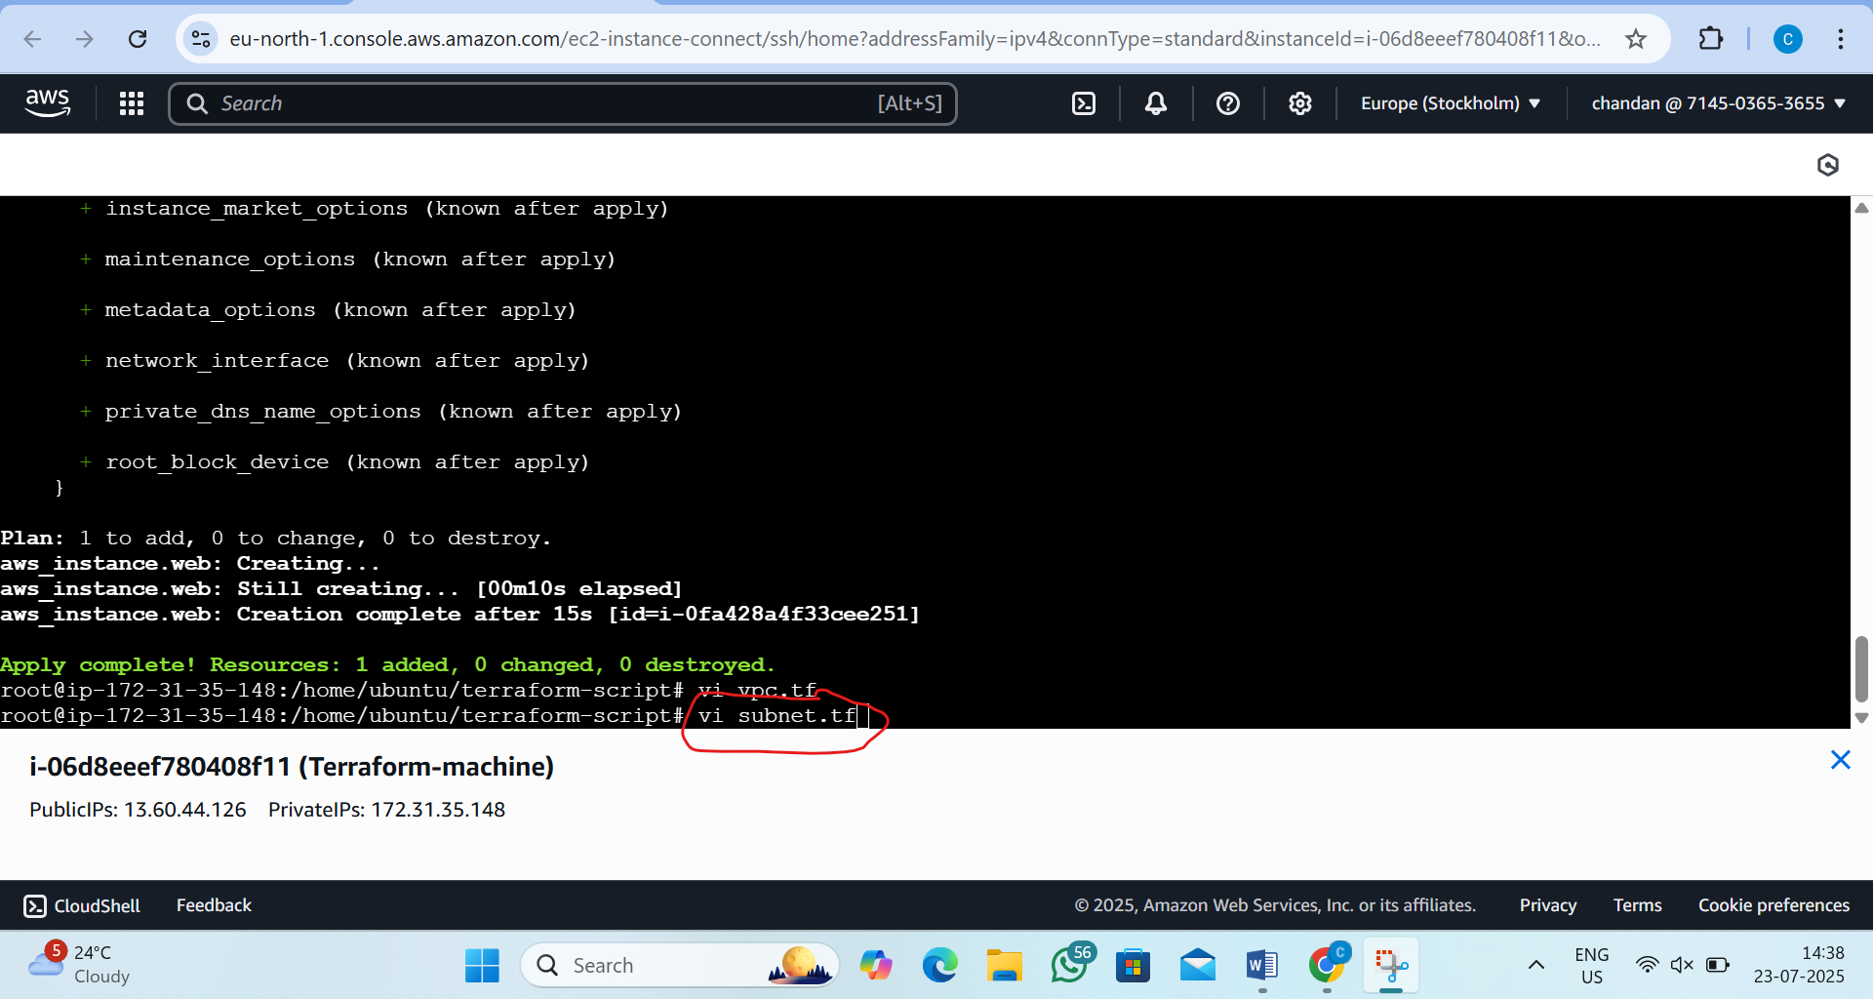

Step26: inside write the script
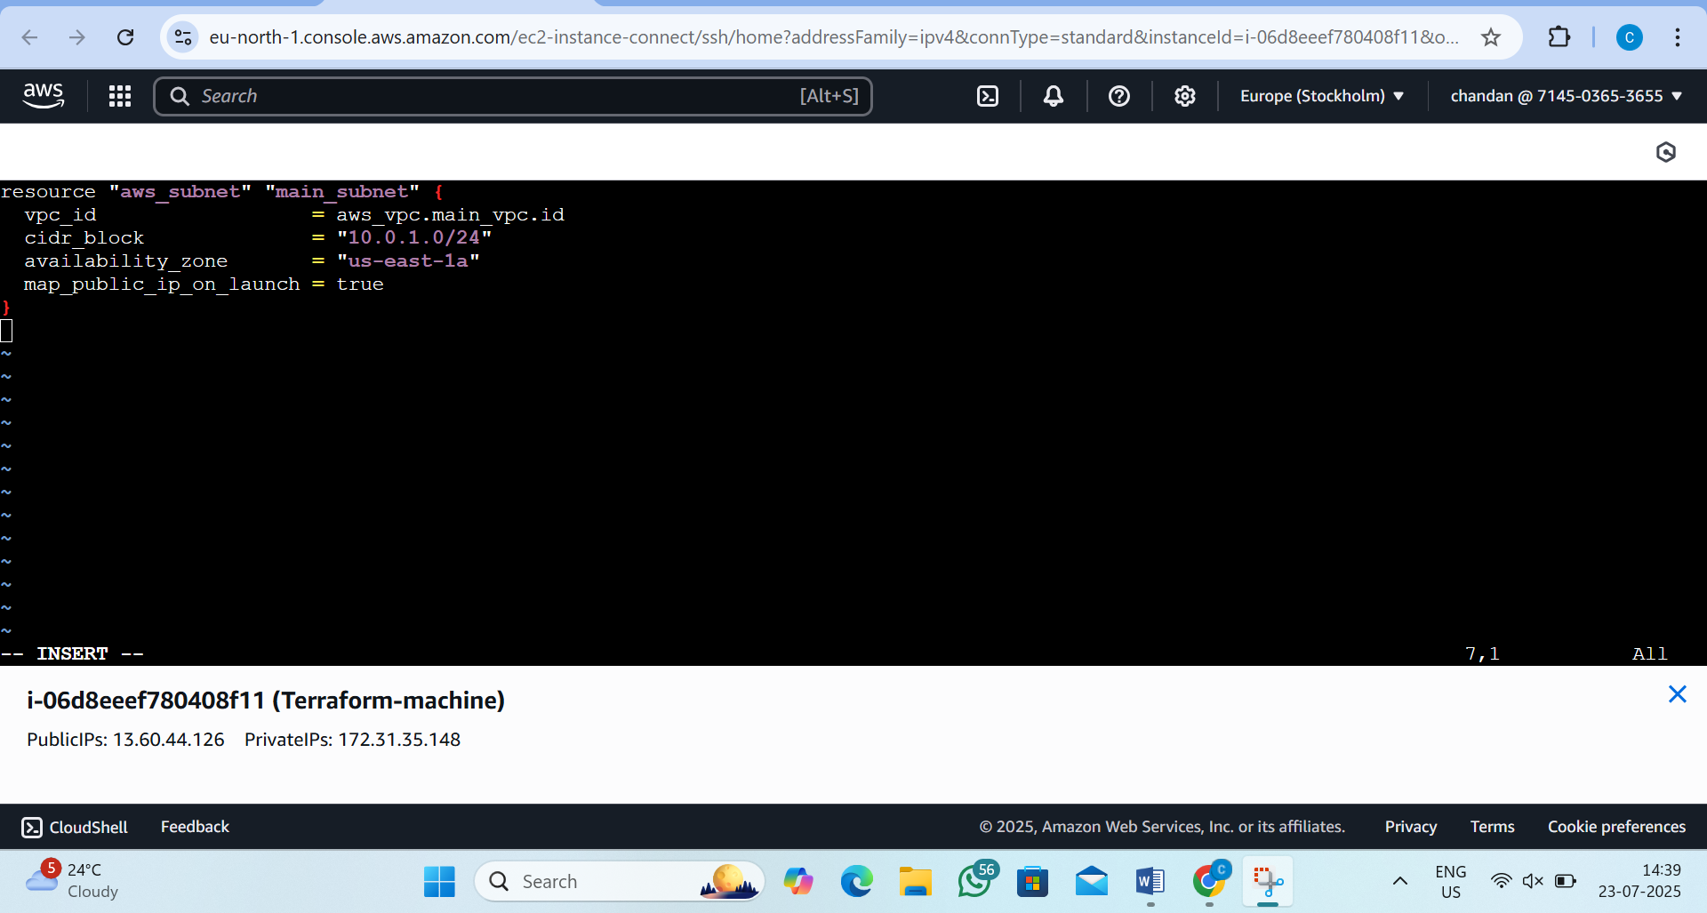
Step27:now create the file internet_gateway.tf
by the command: vi internet_gateway.tf
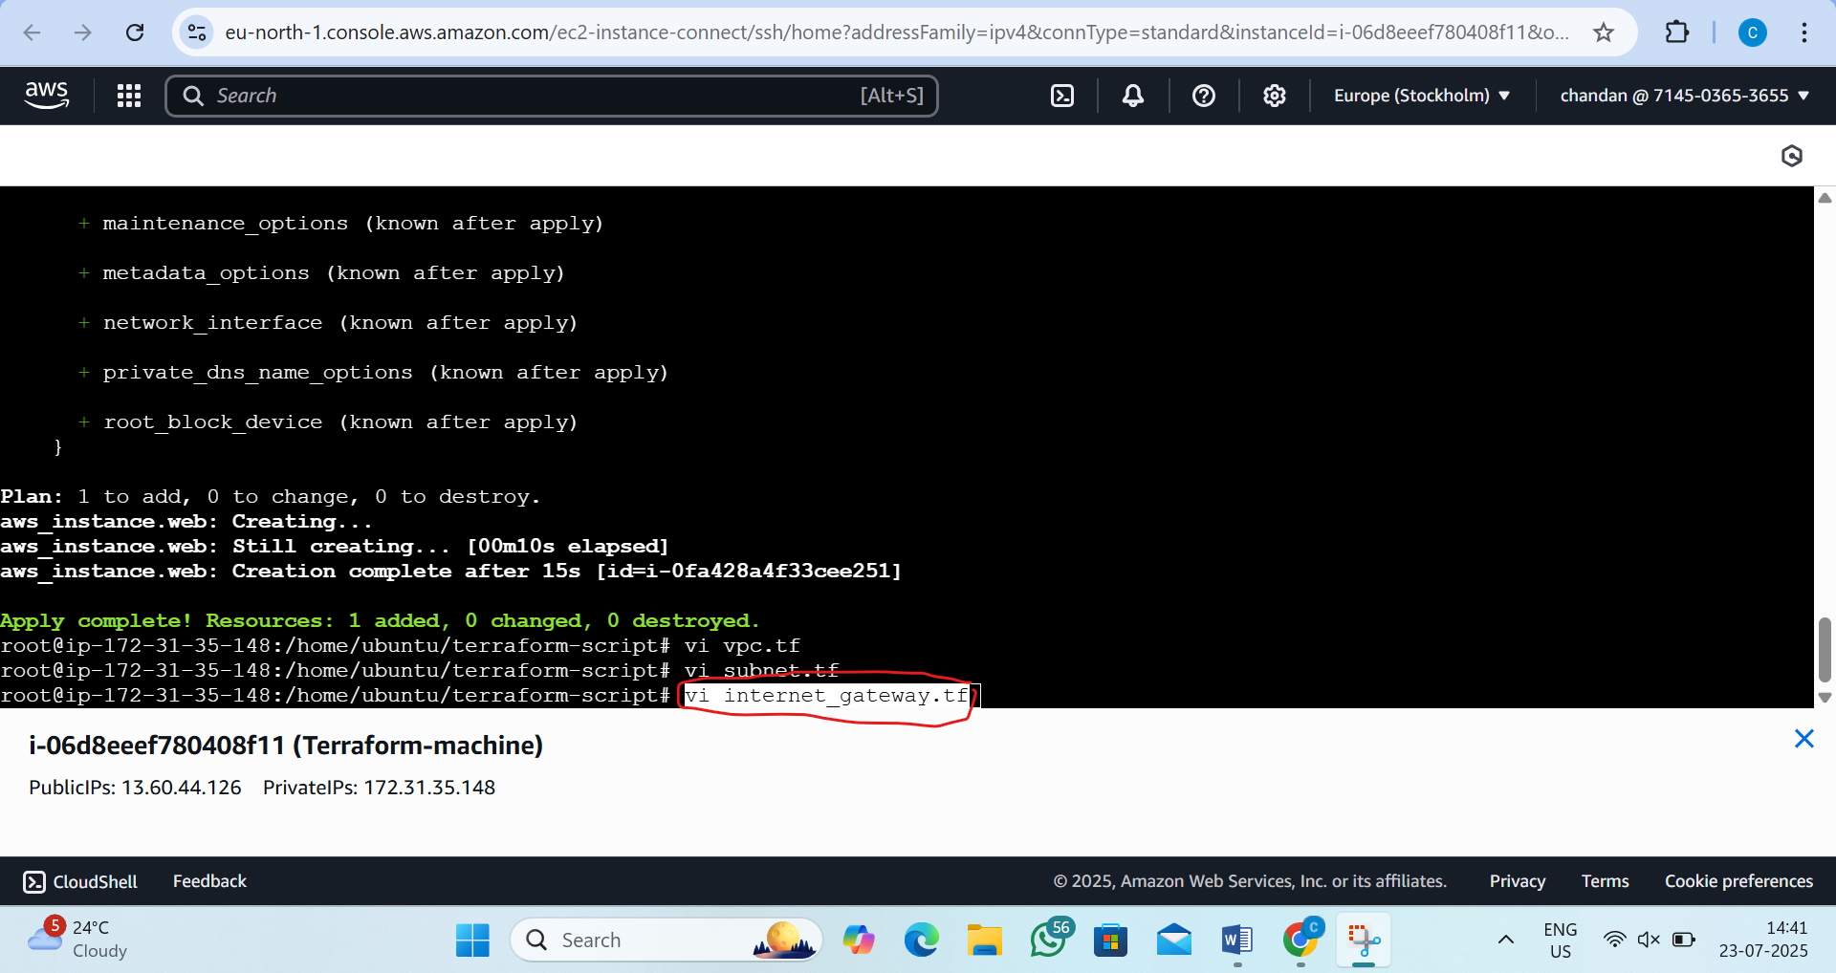

Step28: inside write the script
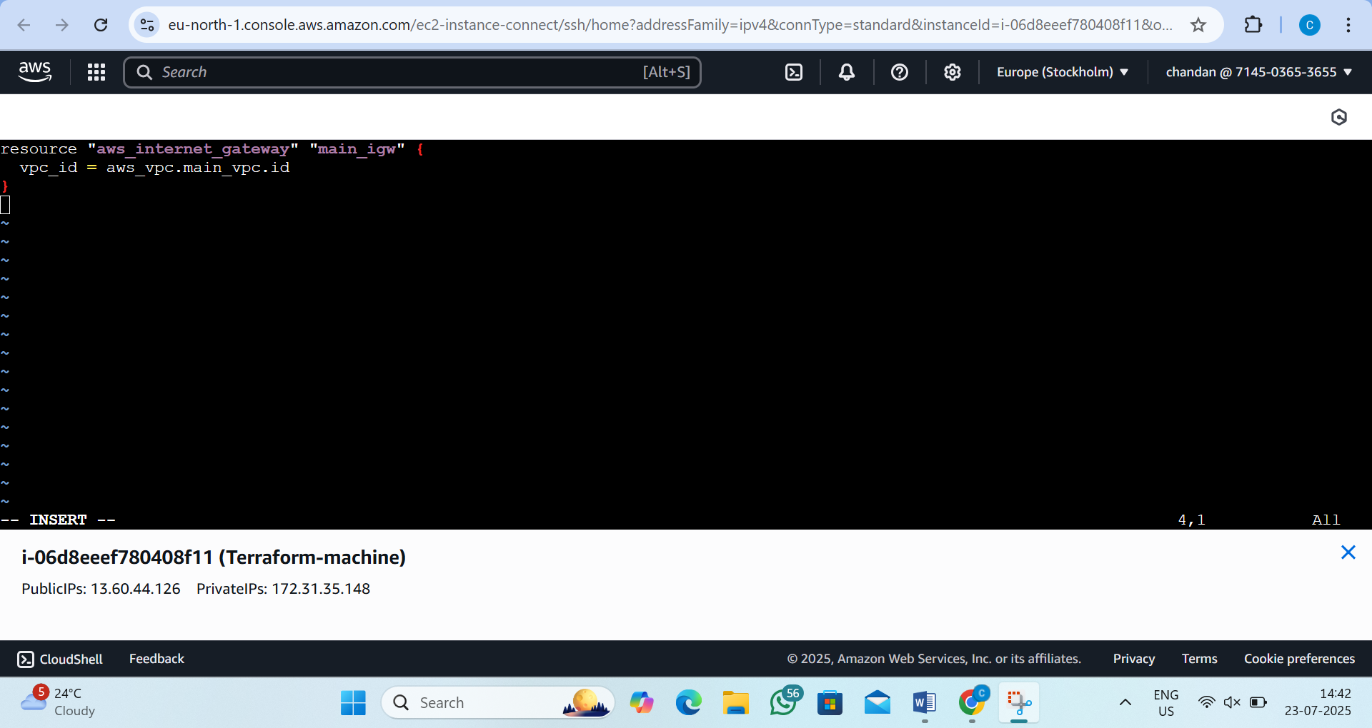
Step29:now create the route_table.tf
by the command:vi route_table.tf
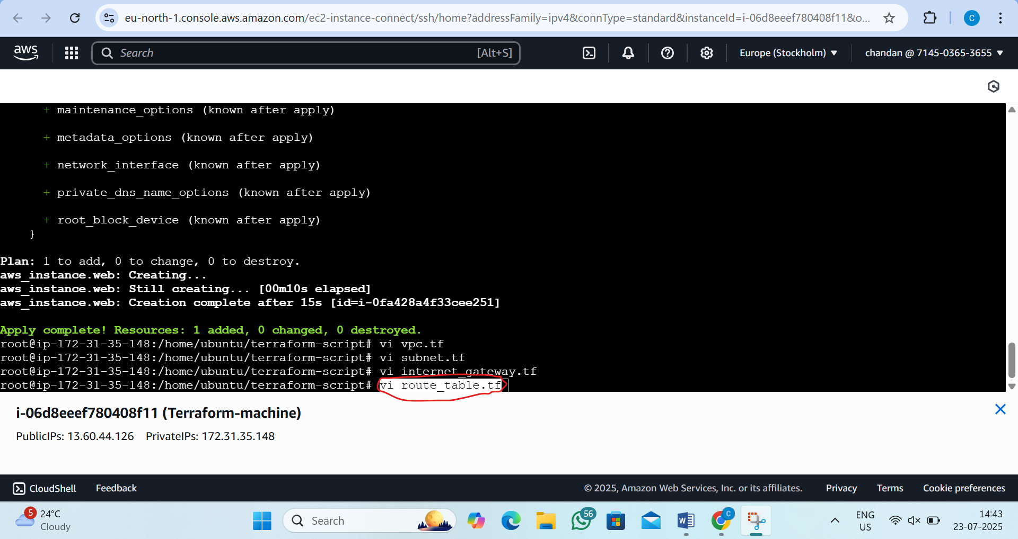

Step30:inside write the script
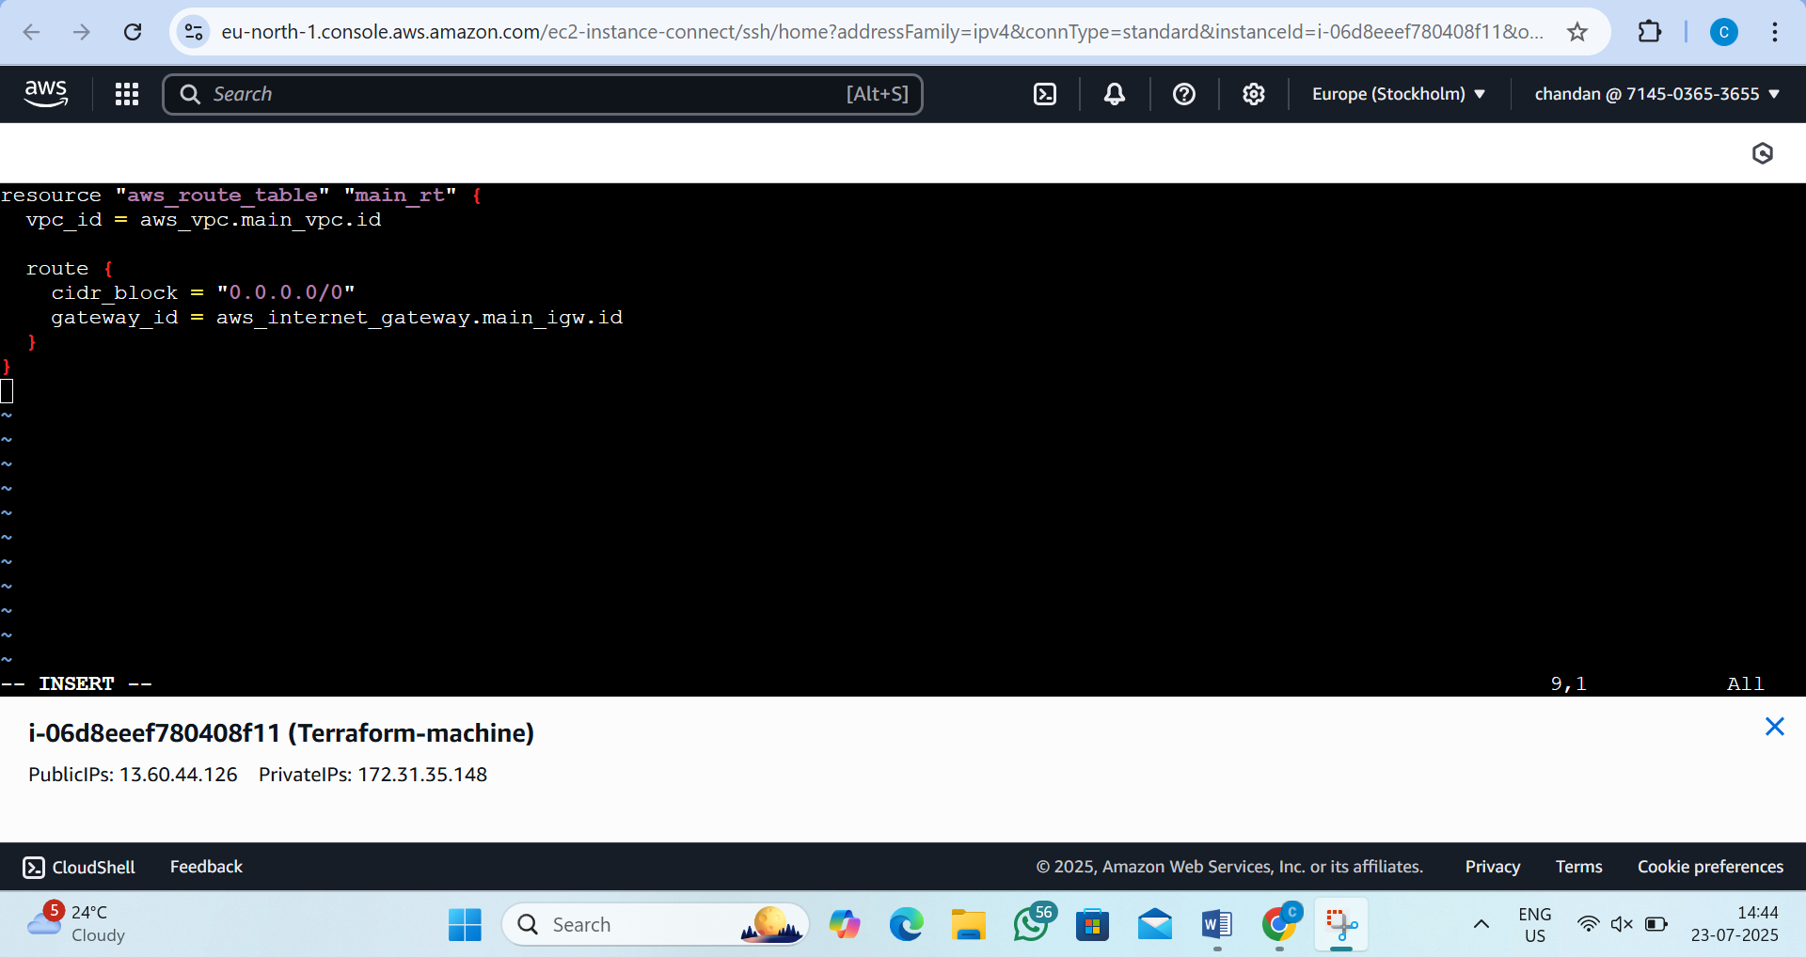
Step31:-now create route_table_association.tf
By the command:vi route_table_association.tf
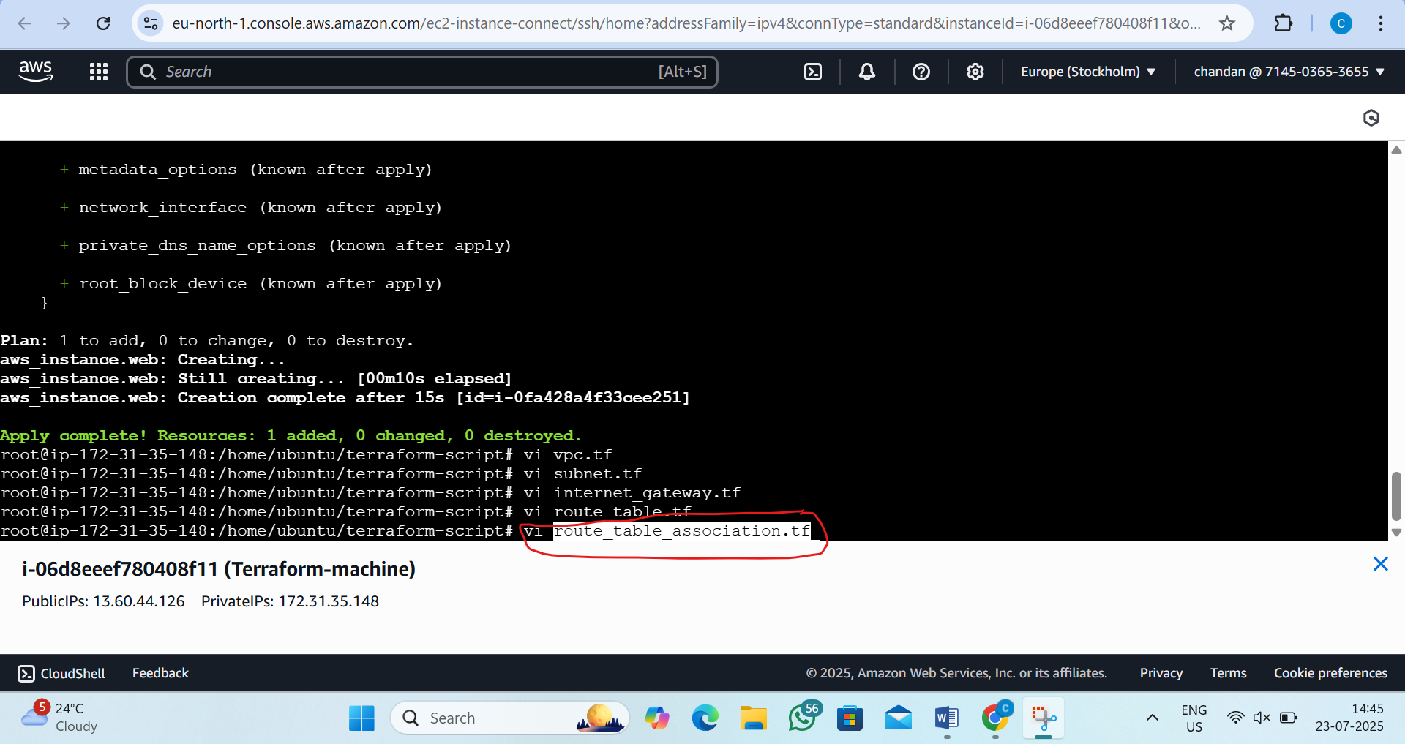

Step32:now write the script inside it
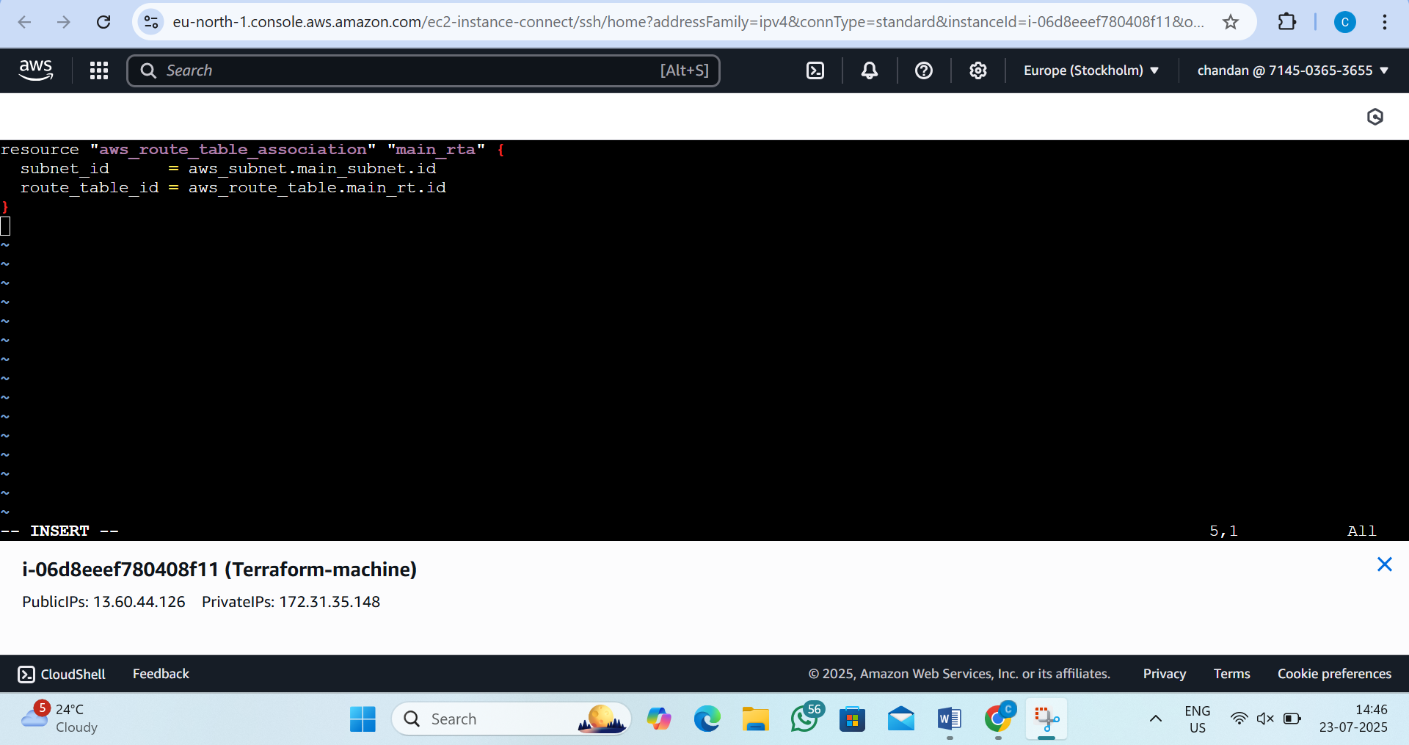

Step33:now create security_group.tf
By the command:vi security_group.tf
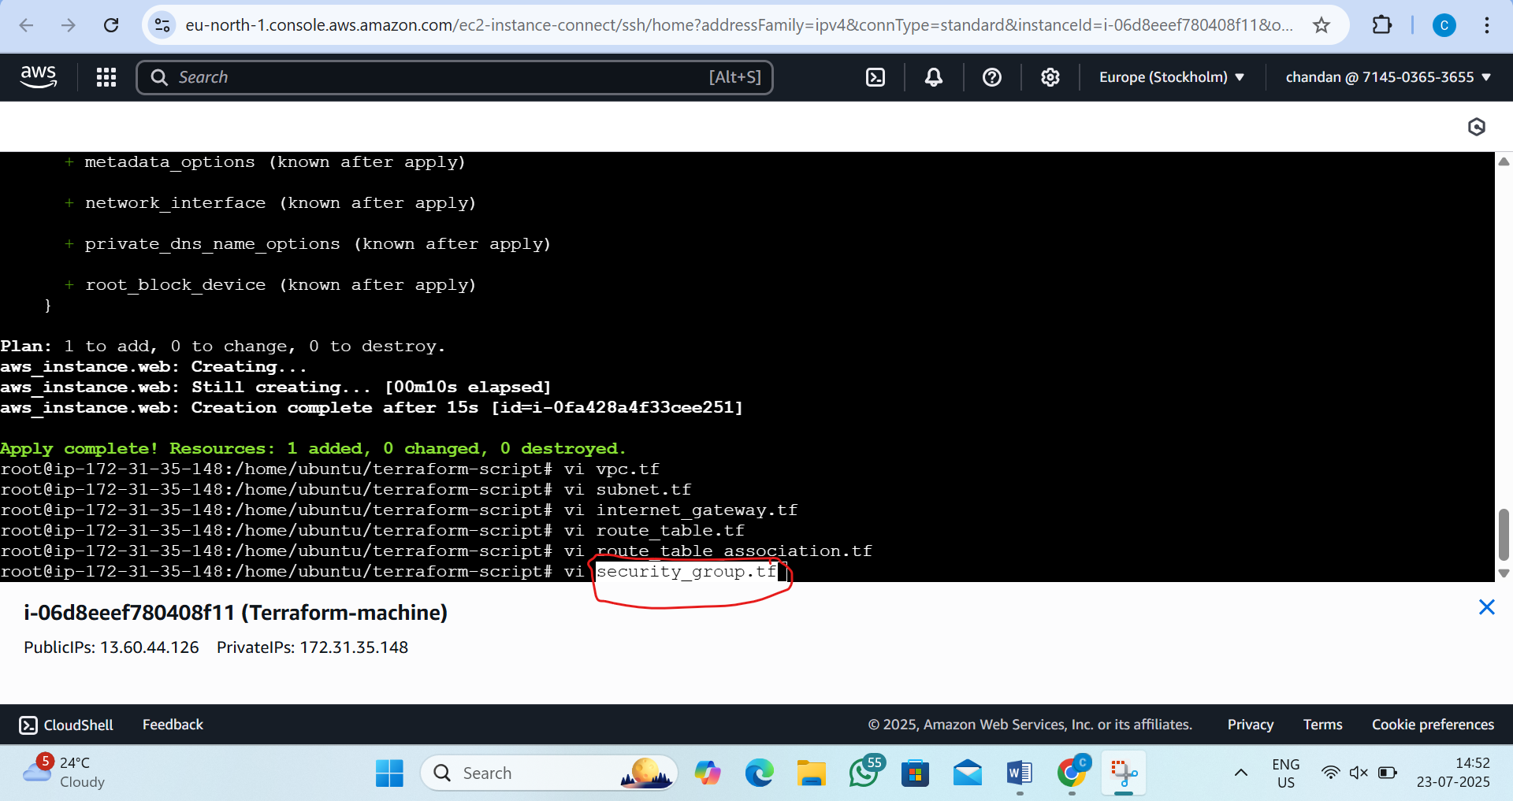

Step34:now write the script inside
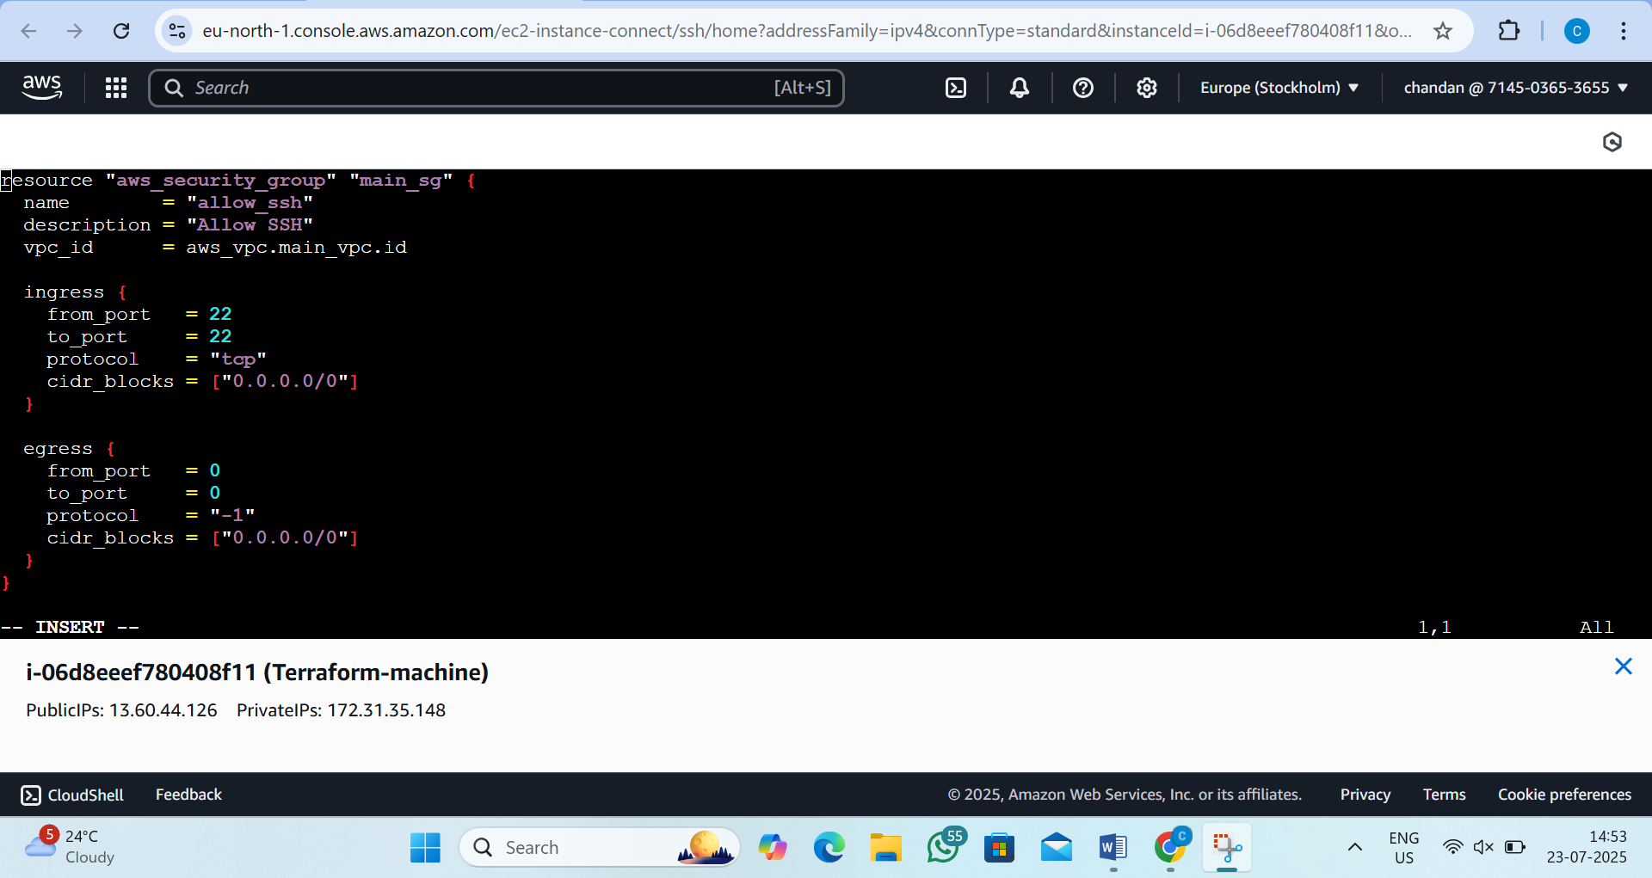

Step35:now go to ec2.tf
by the command:vi ec2.tf
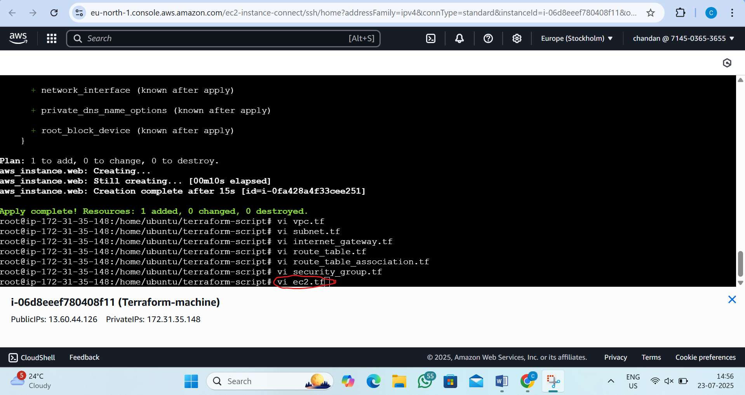

Step36:now write this script
resource "aws_instance" "web" {
ami = "ami-053b0d53c279acc90" # Ubuntu 22.04 LTS in us-east-1
instance_type = "t2.micro"
subnet_id = aws_subnet.main_subnet.id
vpc_security_group_ids = [aws_security_group.main_sg.id]

tags = {
Name = "Terraform-EC2"
}
}

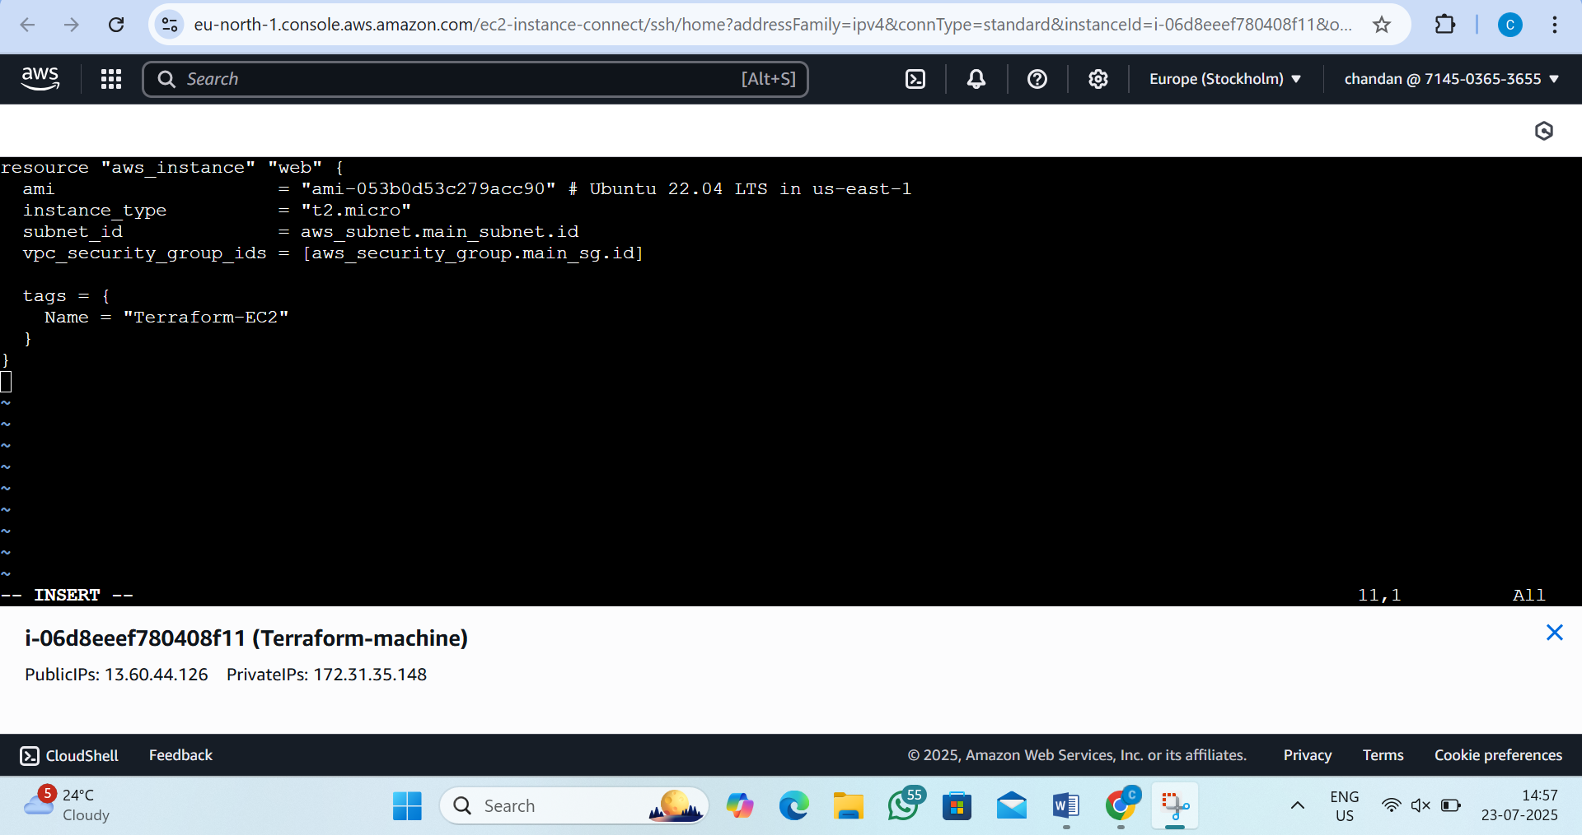

Step37:now ececute
by the command:- terraform apply --auto-approve
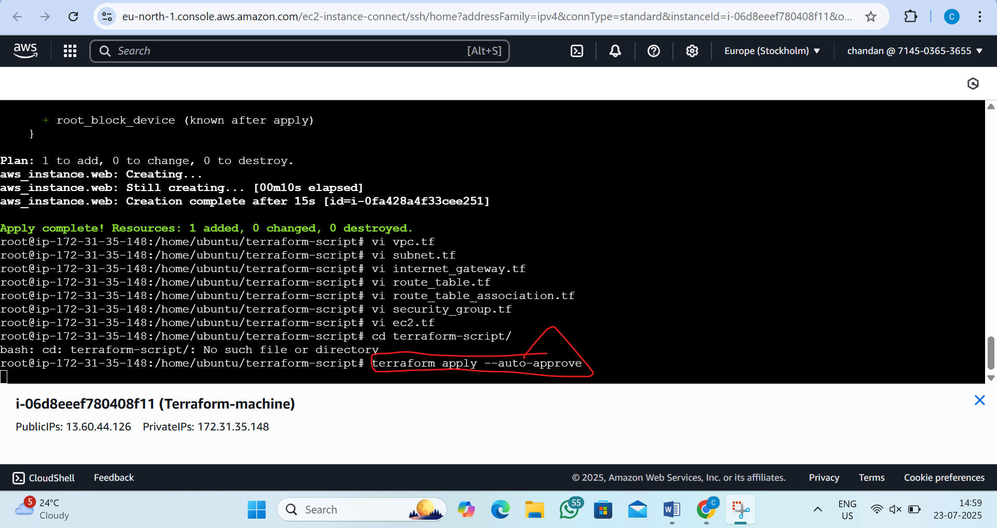
Output is:-
